

**JUSHA Grayscale and Color Auto-calibration Professional Display for Group Consultation**

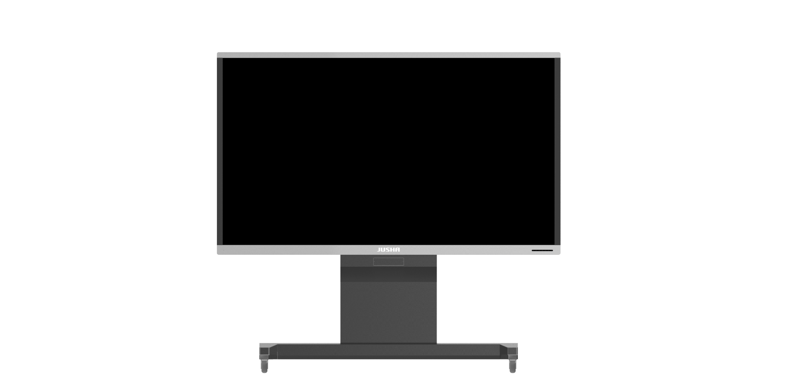

**S9820G**

**User Manual**

**Nanjing Jusha Display Technology Co., Ltd.**

Address: 8A,Block 1,Nanjing International Service Outsourcing Mansion No.301, Hanzhongmen Street, Nanjing, Jiangsu, China

TEL：025-83305050

FAX: 025-58783273

Free Hotline: 400-820-0556 800-820-0556

Website: cn.jusha.com.cn

©All rights reserved! Nanjing Jusha Display Technology Co., Ltd. 2024

Published by Nanjing Jusha Display Technology Co., Ltd.

**Contents**

1. Operating guide 1

1.1 About the Manual 1

1.2 Sign and Symbol Description 1

1.3 Safety Information 2

2. Product introduction 5

2.1 Product Features 5

2.2 Packing list 6

2.3 Front view of display and keys 8

2.4 Rear view of display and its interfaces 11

2.4.1 Power interface of display 11

2.4.2 Signal interface of display 12

2.5 Appearance size 13

3. Display Installation 14

3.1 Preparation Before Installation 14

3.2 Unpacking 14

3.3 Equipment installation 16

3.4 Installation of Graphics Card 22

3.5 Multi-Screen Display Setting 27

3.5.1 Windows XP Operating System Setting 27

3.5.2 Windows 7 operating system setting 27

4. Display Setting 29

4.1 Start the display 29

4.2 Shutting Down the Display 29

4.3 Menu Description 29

4.4 Operate OSD Menu 38

4.4.1 Accessing the On-Screen Display (OSD) Menu 38

4.4.2 Exiting the OSD menu 38

4.4.3 Adjusting Display brightness 38

4.4.4 Adjusting Contrast 38

4.4.5 Adjust digital brightness 39

4.4.6 Select calibration curve 39

4.4.7 Color temperature selection 39

4.4.8 Adjust sharpness 40

4.4.9 Adjust hue 40

4.4.10 Adjust saturation 40

4.4.11 Adjust bypass 40

4.4.12 Adjust ratio mode 41

4.4.13 Adjust zoom mode 41

4.4.14 Adjust noise reduction 41

4.4.15 Adjust input color format 41

4.4.16 VGA channel image automatic adjustment 42

4.4.17 The VGA channel adjusts the horizontal position 42

4.4.18 The VGA channel adjusts the vertical position 42

4.4.19 VGA channel adjusts pixel clock 43

4.4.20 VGA channel adjusts the phase 43

4.4.21 Adjust user mode 43

4.4.22 Adjust display language 44

4.4.23 Image Rotation 44

4.4.24 Test pattern function adjustment 44

4.4.25 Key lock switch 44

4.4.26 Audio input regulation 45

4.4.27 Audio output regulation 45

4.4.28 Volume control 45

4.4.29 Adjust factory setting 46

4.4.30 Ambient light 46

4.4.31 Spotlight 46

4.4.32 Spotlight Type 47

4.4.33 Spotlight Size 47

4.4.34 Laser Pen 47

4.4.35 CGA 47

4.4.36 USB Switch 48

4.4.37 Panel Output 48

4.4.38 Multi-window mode 48

4.4.39 Window Select 49

4.4.40 PIP Size 49

4.5 Signal source selection 49

4.6 Prompt information menu 50

5. Important information 52

5.1 Technical specification 52

5.1.1 S9820 52

5.2 Environmental protection information 52

5.3 Safety standard 52

5.4 Electromagnetic compatibility 53

5.5 Guidance and Manufacturer’s Declaration 53

6. Statement 56

6.1 Legal Statement 56

6.2 Maintenance Statement 57

6.3 Statement of Ownership 58

7. Contact information 59

# Operating guide

## About the Manual

The manual is intended to guide the user in correctly installing, setting up, and operating the professional display for JUSHA grayscale and color auto-calibration group consultation and JUSHA integrated grayscale and color auto-calibration group consultation. Please read this manual carefully before use.

* This product has different specifications. Refer to the corresponding sections of the manual.
* When transferring the product to any third party, it must be accompanied by the manual.
* The product specifications are subject to change without prior notice.
* If there are any other questions about this manual, please contact Nanjing Jusha Display Technology Co., Ltd.

## Sign and Symbol Description

The following signs and symbols are used in the manual and for the product:

|  |  |
| --- | --- |
|  | Annotation information: provide more detailed information for the said object. |
|  | Warning information that prompt user of the possible hazard. |
|  | Hazardous voltage: the warning information that prompt user of the possible electric shock. |
|  | No operating. |
|  | Safe grounding |
|  | * Product conforms to China CCC certification. |
|  | **\*** Product conforms to Part 15 in FCC rules. |
|  | **\*** Product conforms to EN universal standard (certified as per medical device standard) |
|  | *Product can be sold on the North America market. |
|  | European Authorized Representative. |
|  | Users are recommended to treat the recycled product in accordance with WEEE (EU 2002/96/EC Directive, involving the treatment and recycling of waste electrical and electronic equipment). |
|  | Users are recommended to operate with reference to the manual. |
|  | Manufacturer. |
|  | Jusha product LOGO. |
| SN | Product serial number. |

* The display will conform to corresponding certification standard only when the provided power supply is used.

## Safety Information

|  |  |
| --- | --- |
|  | **Note:**  Before installing and operating the display , please read all important safety information. In case of any problem, please contact Nanjing Jusha Display Technology Co., Ltd. (025-83305050). |

**Installation environment**

* Please install the equipment near a convenient power socket.
* Do not use in an environment with a mixture of flammable anesthetic, air, oxygen or nitrous oxide, as it may cause an explosion.
* Do not expose the equipment to rain or damp; never use the display near the water source.
* When installing the base, maintain a minimum distance from the other equipment and the wall. Ensure the side and back of the medical display, when installed, are at least 10 cm away from the wall or 15 cm away from the other equipment. Pay special attention to protecting the panel surface from mechanical impact. For non-fixed installations, ensure they do not pose a safety risk to people or equipment.
* Electromagnetic interference generated by power supply equipment may affect and limit the actual performance of the product, possibly causing product failure. Install this display in an environment with controlled EMI (electromagnetic interference).
* Keep small objects or liquids away from the equipment. If small objects or liquids flow into the equipment, disconnect the power plug immediately and contact our professional maintenance personnel.

**Power Supply and Grounding**

* The disconnecting device for this product is the appliance input socket, located at the lower left of the product’s back. When S9810/S9820 is not in use, please unplug the power cord from the S9810/S9820 through the appliance input socket. Ensure that no other objects are placed near the appliance input socket, to avoid accidentally disconnecting the S9810/S9820 from the power supply.
* Always use the power cord provided with the equipment. Fully insert the power plug into the socket and ensure good contact.
* Do not touch the power cord, insert or pull it out during lightning, as it may cause electric.
* If the power cord needs to be disconnected, grasp the power plug and pull it out. Pulling the power cord may damage the power line and result in electric shock.
* Pay attention to the power supply load capacity, as circuit overload may lead to fire or electric shock.
* Use the correct voltage specified in this manual. Failure to meet the voltage requirements may cause fire, electric shock or equipment damage.
* If the device will not be used for an extended period, disconnect it from the power socket.
* If complete power supply disconnection is necessary, disconnect it from the power socket.
* Ensure that the equipment is properly connected to the required computer or other equipment.
* The equipment must be connected to a protective ground.

**Repair and Maintenance**

* Using malfunctioned equipment may result in fire, electric shock, or equipment damage. If the equipment starts to smoke, emits a scorching smell, or making unusual noise, immediately cut off the power, and contact Nanjing Jusha Display Technology Co., Ltd. for assistance.
* The maintenance must be carried out by qualified personnel. Do not attempt to repair or modify the equipment by yourself, as it may cause equipment damage or personal injury.
* Leaked liquid crystal from the liquid crystal display can have toxic and harmful effects. Avoid contact the damaged liquid crystal display. In case of contact with liquid crystal, clean it thoroughly and consult a doctor immediately.

**Application Suggestions**

* For extremely critical applications, we strongly recommend keeping spare displays available for replacement at any time.
* Avoide squeezing or pressing the display screen to prevent screen damage.
* Do not use sharp objects, such as a pencil or pen, to draw or press on the screen, as it may damage the display. Clean the screen with a clean and soft cloth.
* Avoid direct contact the signal port of the display to prevent potential electrostatic hazards.
* LCD backlight has a certain service life. We strongly recommend using the recommended brightness settings to maximize its lifespan, cand turning off the display when not in use.
* The disposal of waste equipment shall comply with local regulations.
* If the display is not being used correctly, it may interfere with other devices. It is recommended to resolve interference by:
  + Moving or adjusting the affected devices.
  + Installing partition between equipment.
  + Plugging the two devices into different power sockets.

|  |  |
| --- | --- |
|  | **Note:**  Indoor use only! |

# Product introduction

Thank you for choosing the JUSHA professional displays.

* S9810/S9820 is a grayscale and color auto-calibration group consultation display with LED backlight.

These professional displays are designed to deliver high-quality video and image for medical image consultations, medical image teaching, telemedicine, electronic education centers, digital operating rooms, and more.

## Product Features

* **High Resolution**

With resolutions of up to 8 megapixels, pixel particles become smaller, enabling comprehensive display of medical image details and fulfilling exact diagnosis demands of medical institutions.

* **16-bit Gray Scale Display**

Featuring a 16-bit (RGB) gray scale display and 48-bit color display, our system showcases up to 65,536 gray scales, and presents up to 281 trillion colors, This allows for finer display, smoother screen transitions, and perfect presentation of medical images details.

* **Conformance to DICOM Standard**

To ensure the accurate image display, JUSHA meticulously measures and sets each gray scale during display production to meet DICOM standard, providing consistent and precise image representation.

* **Focused Display**

Our system provide three-gear variable circle or rectangle on the screen, centered at the mouse position, and available in large and small size. Outside the circle or rectangle area, display brightness is reduced, and while within them, display and focus are enhanced for easier diagnosis.

* **Laser Pointer**

Featuring a circular centered at the mouse position, with a default radiu 11 pixels, the laser pointer presents in red with a black border. This tool allows for precise indication of specific areas by the mouse.

* **Ambient Light Self-Adaption**

Activate ambient light function protects physicians’ vision by adaptively regulating screen brightness according to ambient brightness levels.

* **Ambient Light Compensation**

Our system adjusts to various environmental conditions using the monitoring input of an ambient light sensor, ensuring accurate image reading under diverse conditions and meeting medical specifications and diagnostic requirements.

* **Multi-Screen Display Function**

In addition to single-channel images, our system can seamlessly display multi-channel images, accommodating up to four channel images on a single screen for enhanced imaging diagnosis and analysis.

* **Patent CGA Technology**

Utilizing JUSHA’s patented technology, our system is able to recognize the color and gray scale signals in the input signals, correcting color signals with GAMMA and gray-scale signals with DICOM, thus enabling simultaneous display of color and gray-scale images.

* **Energy-Saving Mode**

When not in use, the device enters sleep mode, consuming less than 0.5W of power, promoting energy efficiency.

|  |  |
| --- | --- |
|  | **Note:**  To use the focused display, laser pointer, and CGA functions, the following conditions must be met:  1. The monitor must be connected to the computer host via a USB cable.  2. The "JUSHA DisplayExpert 2.0" software must be installed. |

## Packing list

The packaging box for JUSHA grayscale and color auto-calibration group consultation display and JUSHA integrated grayscale and color auto-calibration group consultation display may include the following items:

* LCD
* Pedestal/Wall hanging rack (optional)
* Screws
* DP cable/ HDMI cable/ USB cable
* Remote control
* Stylus
* Light disk and sleeve
* Packing list
* Wireless keyboard and mouse
* User manual
* Work gloves

|  |  |
| --- | --- |
|  | **Note:**   1. The packing list provided here is for reference only, and is subject to the one contained in the packing box. 2. In the event of damage or loss of any accessory listed in the packing list, please contact us without hesitation. 3. Never use the accessories from third parties, such as the power adaptor and graphics card. Nanjing Jusha Display Technology Co., Ltd. will not be responsible for any technical problems caused by third-party accessories. 4. Please ensure that the original packaging is kept in good condition. If the product needs to be transported again, the original package must be used. |

|  |  |
| --- | --- |
|  | **Note:**  S9820, S9820G, S9820M, S9820L, S9820E, S9820S, S9820*****, JUSHA-S9820, JUSHA-S9820G, JUSHA-S9820M, JUSHA-S9820L, JUSHA-S9820E, JUSHA-S9820S, JUSHA-S9820*****, S9810, S9810A, JUSHA-S9810, JUSHA-S9810A, JUSHA-SUPER98T, JUSHA-SUPER98T-A, JUSHA-SUPER98T-AIO, S98****, S98****-****, S98****A, S98****A-****, JUSHA-SUPER98**T, JUSHA-SUPER98**T-A, JUSHA-SUPER98**T-AIO ("*"=0-9, A-Z or blank means different customers and sales markets, which does not affect safety and EMC), product information, corresponding operation Settings and specifications can be referred to S9820. |

## Front view of display and keys

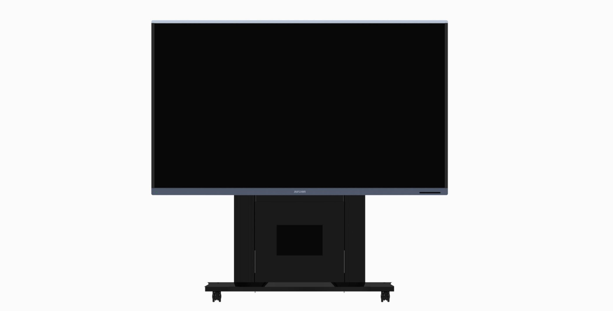

C:\Users\Admin\Desktop\触摸按键丝印.jpg

|  |  |  |
| --- | --- | --- |
| **Keys** | | **Functions** |
| ➊ | （INPUT） | 1. Bring up the signal source selection menu if it is not currently displayed. 2. Confirm the selected signal source channel when the signal source selection menu is visible. 3. In the main menu, choose the option that requires pressing the "confirm" key to execute the function: "Confirm" key. |
| ➋ | (LEFT） | * + - 1. When selecting the progress bar adjustment mode, decrease the value of the progress bar indicator parameter.       2. Switch to the previous option when selecting the sub-option adjustment mode.       3. No menu display: CGA switch shortcut key.       4. Volume adjustment prompt, reduce the volume in the menu. |
| ➌ | （RIGHT） | When selecting the progress bar adjustment mode option, include the progress bar indicator parameter value.  Choose the sub-option adjustment mode to switch to the next option.  Display the key lock unlock prompt menu as “Key Lock Unlock”.  Display the volume adjustment prompt menu “Increase The Volume”.   1. If no menu is available, use the volume adjustment shortcut key to access the volume adjustment menu. |
| ➍ | （DOWN） | * + 1. No menu: lifting base adjustment shortcut key.     2. The main menu display: menu down.     3. When the lifting base prompt menu is displayed, press and hold to adjust the height of the lifting base. |
| ➎ | （UP） | 1. No menu: spotlight switch shortcut key. 2. When the main menu is displayed, the menu goes up. 3. When the lifting base prompt menu is displayed, long press to adjust the height of lifting base. |
| ➏ | （MENU） | 1. When there is no menu, call up menu options. 2. If there is a menu, return to the upper-level menu or exit the menu. |
| **➐** | （POWER） | Switch power on and sleep mode |

|  |  |
| --- | --- |
|  | **Note:**  Power indicator  1. When the device is not powered on, the indicator is off.  2, Power on, do not turn on, the indicator is red.  3. Power on. When it is powered on, the indicator is green.  There are various key marks on the key pad. For specific operation methods and functions, please refer to the section "4 Setting of the Parallel Consultation Center". |

**Function description of remote control：**



|  |  |  |  |
| --- | --- | --- | --- |
| **序号** | **名称** | **图标** | **描述** |
| 1-7 | INPUT  LEFT  RIGHT  DOWN  UP  MENU  POWER |  | It has the same function as the body buttons |
| 8 | Mute key |  | 1. If there is no menu, switch the mute switch directly.  2.When the main menu is displayed, it has no effect. |
| 9 | Spotlight shortcut |  | 1. When there is no menu, switch the spotlight switch directly  2.When the main menu is displayed, it has no effect |
| 10 | Single - and dual-screen shortcut keys |  | 1. If there is no menu, switch between the single-screen and dual-screen  2.When the main menu is displayed, it has no effect |
| 11 | CGA shortcut key |  | 1. If there is no menu, switch the CGA switch directly  2.When the main menu is displayed, it has no effect |
| 12 | Shortcut key for lifting base |  | This model is not currently supported |

## Rear view of display and its interfaces

### Power interface of display

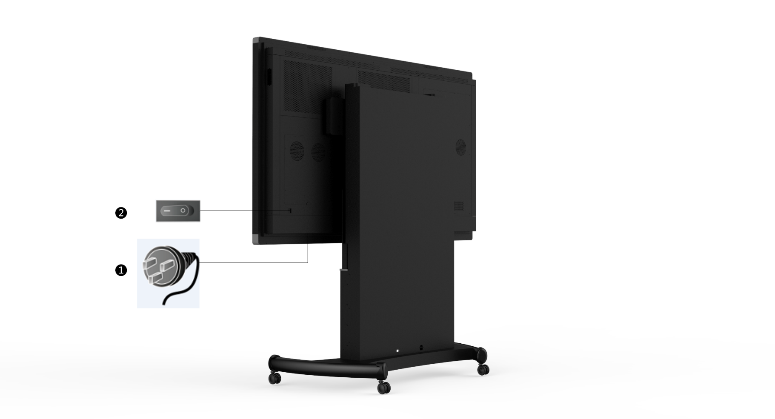

The illustrated position is for illustration only. The actual position shall prevail

**Applicable for display interface:**

|  |  |
| --- | --- |
|  | AC power socket |
|  | AC power switch |

|  |  |
| --- | --- |
|  | **Warning:**  The disconnecting device of this product is the appliance input socket, which is located on the lower side of the back of the product. When the monitor is not in use, please unplug the power cord from the monitor through the appliance input socket, and no other objects shall be placed near the appliance input socket, so as to avoid the disconnection of the monitor and the power supply. |

### Signal interface of display

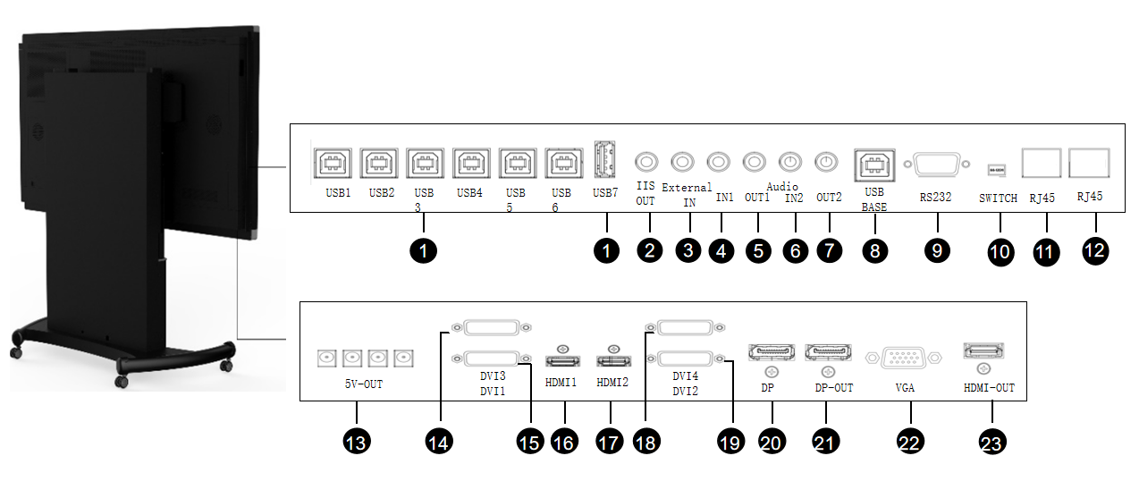

**Signal interface of display and corresponding specification**

|  |  |  |
| --- | --- | --- |
| No. | Signal interface | Specification |
| 1 | USB interface | USB-B*6,USB-A*1 |
| 2 | IIS OUT | IIS OUT |
| 3 | External IN | MIC input |
| 4 | Audio IN1 | Audio input |
| 5 | Audio OUT1 | Audio output |
| 6 | Audio IN2 | Audio input |
| 7 | Audio OUT2 | Audio output |
| 8 | USB BASE | Standby interface |
| 9 | RS232 | Serial port |
| 10 | SWITCH | Serial port and network communication options |
| 11 | RJ45 | Network port |
| 12 | RJ45 | Network port |
| 13 | 5V power output port | DC005B/DC002*4/1A |
| 14 | DVI3 input interface | Single-link DVI-D |
| 15 | DVI1 input interface | Dual-link DVI-D |
| 16 | HDMI1 signal input interface | HDMI1.4 |
| 17 | HDMI2 signal input interface | HDMI1.4 |
| 18 | DVI4 input interface | Single-link DVI-D |
| 19 | DVI2 input interface | Dual-link DVI-D |
| 20 | DP signal input interface | DP1.2a |
| 21 | DP signal output interface | DP1.2a |
| 22 | VGA | VGA input interface |
| 23 | HDMI-OUT | HDMI signal output interface |

## Appearance size

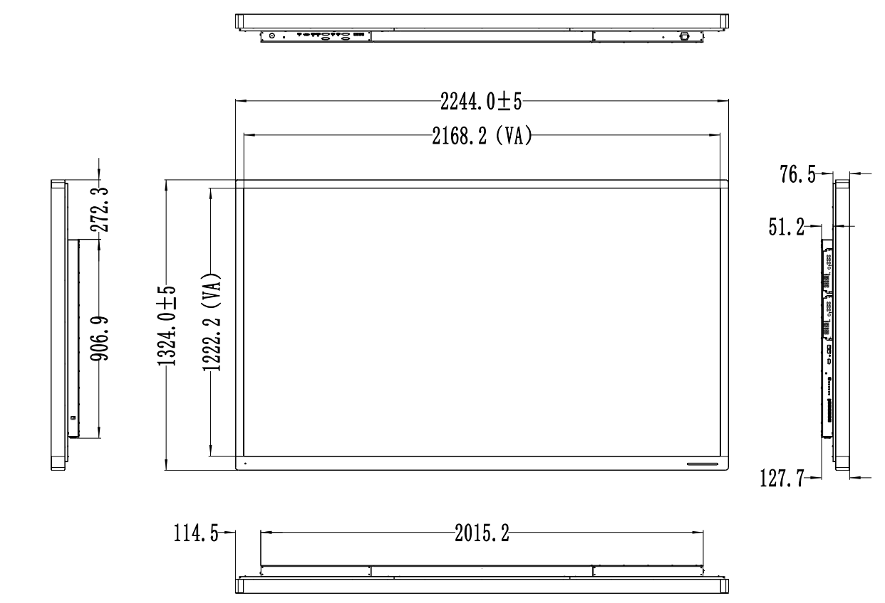

*Unit (mm)

# Display Installation

## Preparation Before Installation

Some tools need to be prepared before installation, and the list of required tool lists is shown below:

|  |  |
| --- | --- |
| No. | Tool |
|  | Cross-shaped screwdriver |
|  | Socket head wrench (M8 and M10) |

## Unpacking

Remove the medical display from the flight case:

* + - 1. Engage the foot brake on the wheels of flight case.

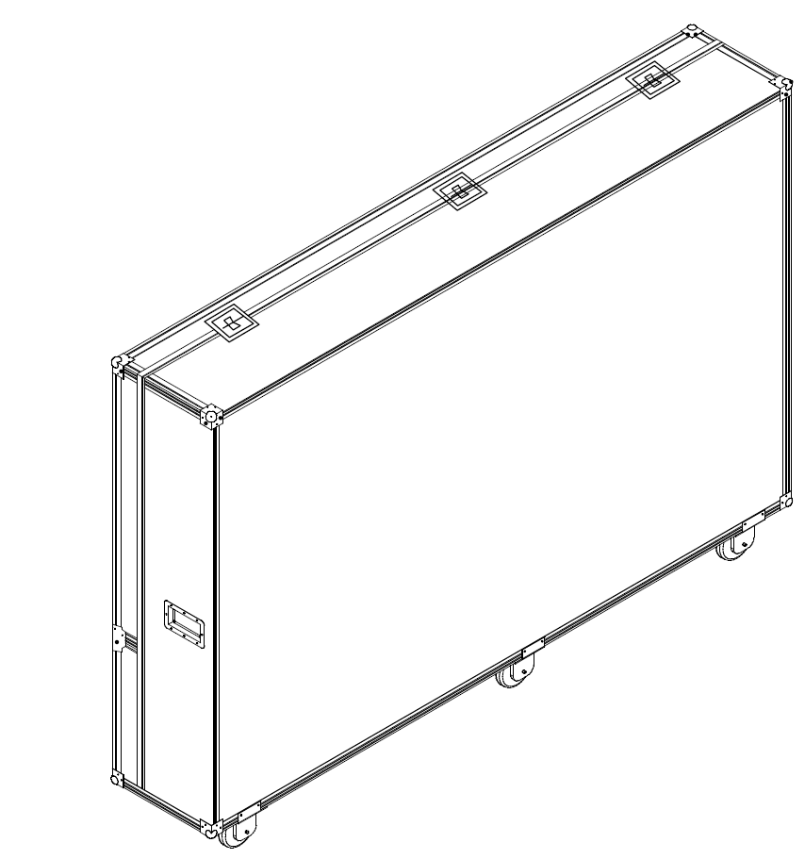

* + - 1. Unlock the seven fixing locks on the case, remove the upper part on the side of case carefully, take out dotted gloves from accessory box and wear the gloves.

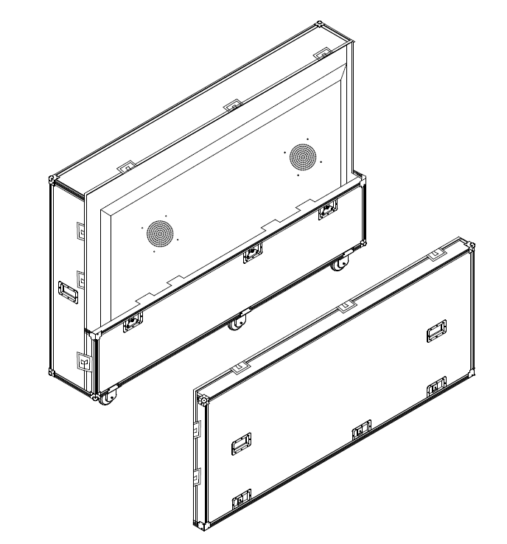

* + - 1. Unfasten the clip located at the lower part of the case’s side, rotate it, and place it on the ground.

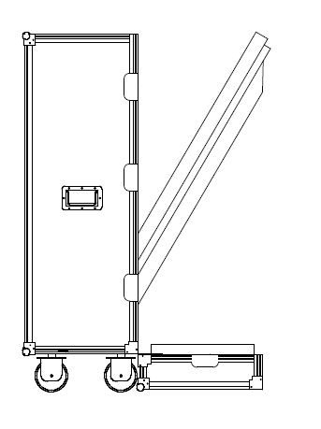

4. Take out the medical display carefully from the case.

|  |  |
| --- | --- |
|  | **Note:**  1. The medical display may fall down after the lower part of flight case is removed, and therefore the user must take proper precautions to prevent such an occurrence removing the display.  2. Unpacking medical display case must be done by at least two people.  3. Take appropriate safety measures to prevent injury caused by falling equipment. |

## Equipment installation

* Remove mounting parts from packaging, install casters through the-threaded holes in the bottom of the base and tighten them:

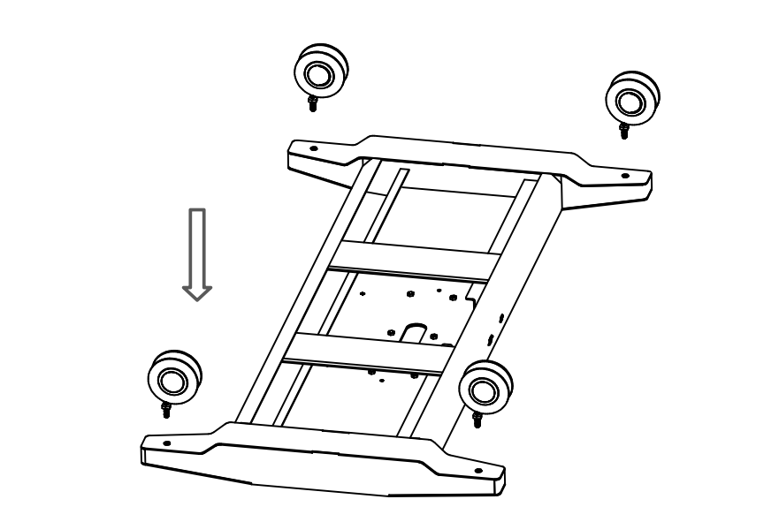

* Install the decorative assembly on the post with a cross screw and attach the screws (M4x8, 8 in total). Then, position the column with the front decorative plate on the base using the positioning hole. Secure the posts and bases with six hex screws (M8x30 ,6 in total), and tighten the screws with a hex wrench.



* Place the host tray (with slide rail) on the column in the direction shown below, and then install the screws (M4x8 ,4 in total). Tighten the screws with a cross head screwdriver.



* Position the rear and lower decorative plate on the post in the direction shown in the following figure, install 10 screws (M4x8, 10 in total). Tighten the screws using a crosshead screwdriver.

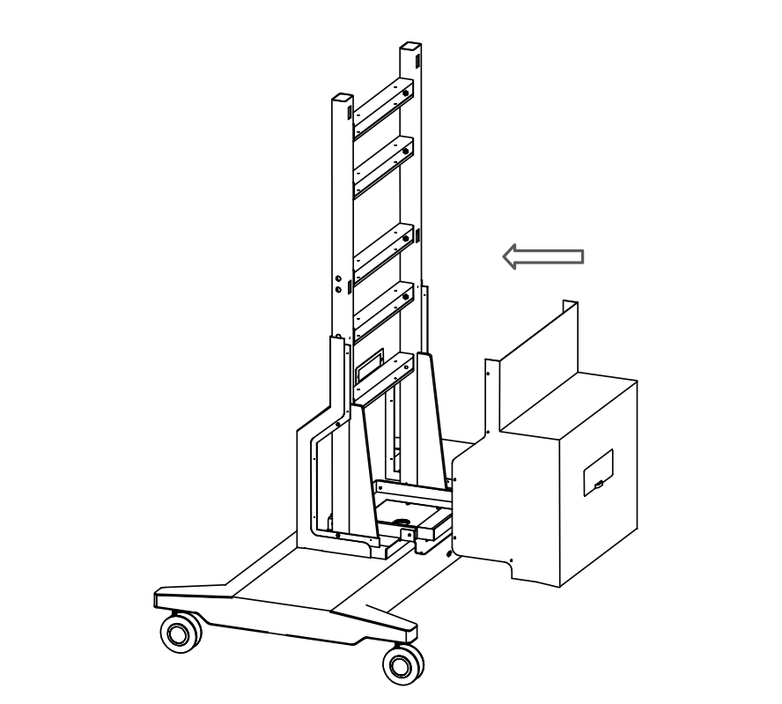

* Raise the monitor and hang the two hooks at the back of the machine onto the two beams at the upper end of the strut. Install two hexagon screws (M10×30, 2 in total) at the arrows shown to secure the display and the base post.



|  |  |
| --- | --- |
|  | **Note:**  During installation, ensure the screen is flush on the left and right sides. After installation, both sides of the hook edge should align with both sides of the column beam edge. |

* Place the rear upper decorative plate on the column from the direction shown in the figure below.



* The following figure shows the installation effect.



|  |  |
| --- | --- |
|  | **Note:**  The installation method is for reference only, and the specific installation method shall depend on the real object. |

**Warning:**

* Please connect the display with the power lines shown in the table below. If the power line does not match the product, contact the supplier. To avoid accidents, use approved power lines conforming to national safety standards that match the voltage of the power socket.
* To avoid electric shock, the power lines must be connected to the ground power supply.
* Power line: When using a display with voltage of more than 120 volts is to be used, the display shall be powered by a center tap circuit. Additionanlly, the display may require different power cord plugs in different countries, as shown in the following table.

|  |  |  |  |
| --- | --- | --- | --- |
| District/Nation | USA, Canada | EU (exception for UK) | UK |
| Plug type |  |  |  |
| Standard | ANSI/UL 817 CSA-C22.2 No.21 | DIN VDE 0620-1:2010 | BS1363/BS546 |
| Voltage | 120V | 230V | 230V |
| District/Nation | Brazil | Japan | South Korea |
| Plug type |  |  |  |
| Standard | NBR14136 | JIS 8303 | KSC8305:2002R |
| Voltage | 220V | 110V | 220V |
| District/Nation | Denmark | Singapore | China |
| Plug type |  |  |  |
| Standard | SB 107-2-D1 | SS145 | GB15934-2008 |
| Voltage | 230V | 230V | 220V |

## Installation of Graphics Card

|  |  |
| --- | --- |
|  | **Note:**  1. Before installing the graphics card, ensure that the mainboard of your host computer supports a standalone graphics card and has a separate blank PCI-E slot.  2. The installation method for graphics card and card drive provided in this manual is for your reference only. The installation method may vary for different graphics cards and drives. An example of the graphics card is the AMD Radeon HD230.  3. The graphics card is positioned correspondingly to the PCI-E interface positioning port. |

1. Before installing the graphics card, turn off the computer and disconnect the power line to ensure that the computer is not receiving power.
2. Open the computer chassis to locate the available PCI-E slots. Remove the metal dampers at the back of their corresponding chassis to prevent them from obstructing the graphics card installation.
3. Align the connecting finger part of graphics card with the mainboard PCI-E interface, and fully insert the display card into the main board PCI-E slot by hand until the card is securely in place.
4. Secure the graphics card to the computer chassis using screws.
5. If the graphics card requires independent power supply, please connect to the power supply line.
6. After the graphics card is installed, reattach the opened chassis and connect the display to the card. Then, reconnect the power line and turn on the computer.

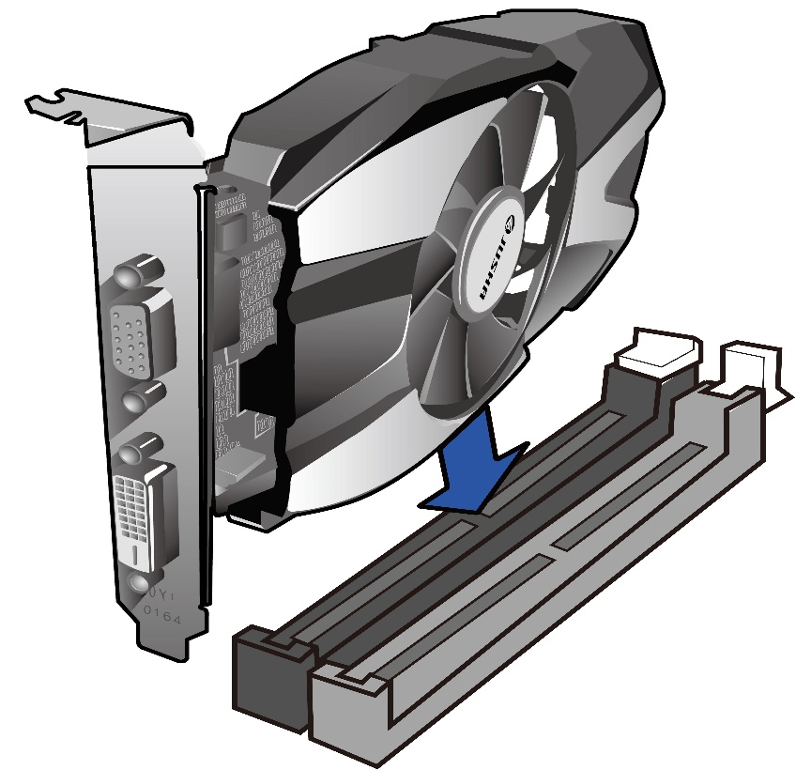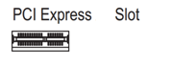

1. Since the graphics card driver has not yet been installed yet, the computer operating system may provide a default low resolution for the display, such as 800×600.
2. Insert the graphics card installation disk in the display accessories into the CD driver and select the corresponding display card driver for installation. For Windows 7 or Windows 8, select “JUSHA-HD230 Win7 Win8.exe”; For Windows XP，select “JUSHA-HD230 WinXP.exe”.
3. Enter "Welcome Interface", select the display language, for example, English.

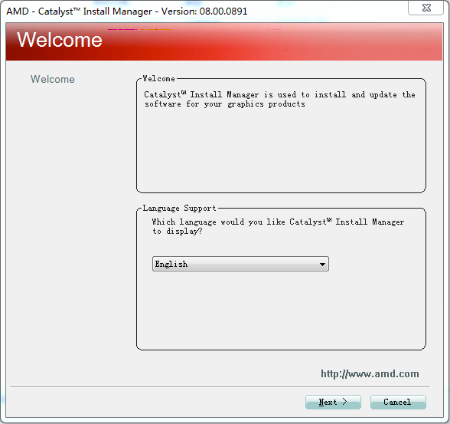

1. Click Next to enter the Select Installation Operations interface.

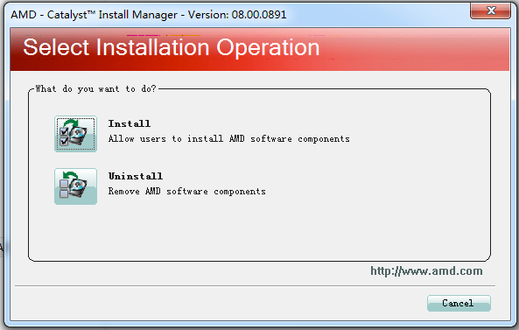

1. Click the "Install" icon to enter the "Welcome to Setup" interface. Select the installation path for drives. If you are not familiar with the drive installation settings, we recommend using the default path, selecting Fast, and then clicking Next.

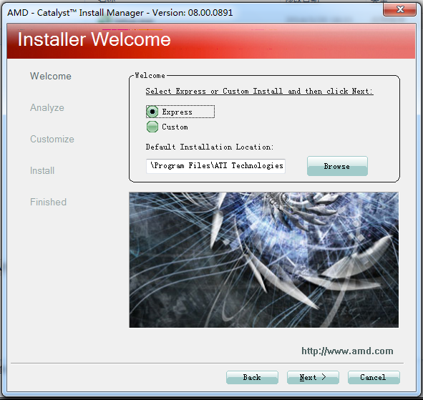

1. Enter the End User License Agreement interface and click Accept.

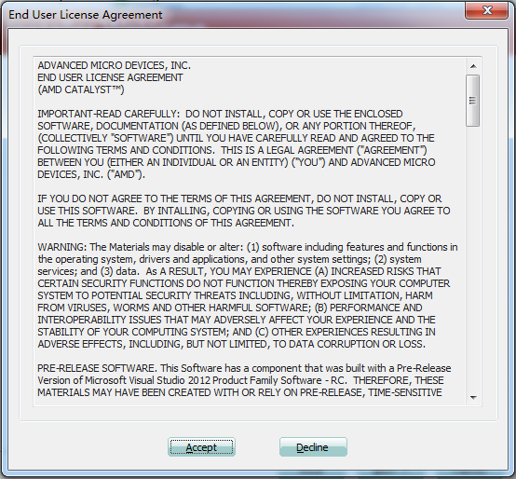

1. Enter the "Install" interface. Wait patiently as the components are installed automatically.

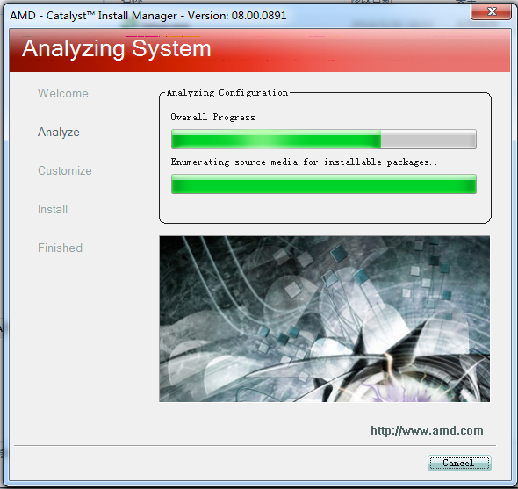

1. Finally, the "Complete" interface automatically pop up.

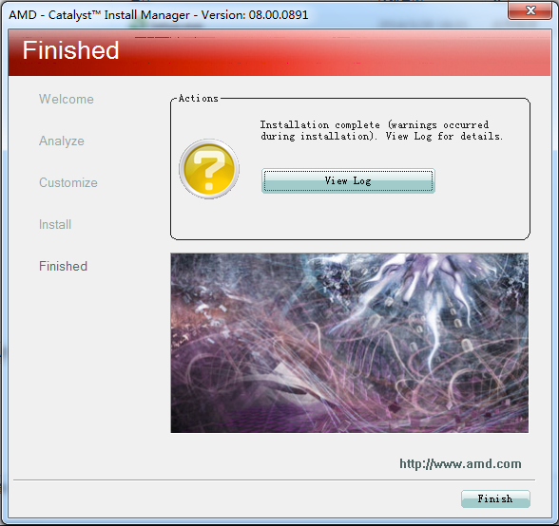

1. The computer must be restarted after installation.
2. After the computer is restarted, check the status of display adapter in the Device Manager. If the operating system identifies the display adapter as “AMD Radeon HD R5 230”, it indicates that the display card drive has been successfully installed.

## Multi-Screen Display Setting

The Windows operating system supports multiple screen extension display, which has brought great convenience to people's work. For example, a doctor may use two displays simultaneously, one for diagnosis and the other for writing diagnostic reports or reviewing previous medical records of a patient. The setting method for multi-screen display is introduced below.

### Windows XP Operating System Setting

1. Connect DVI, HDMI, or DP on the graphics card to the corresponding DVI, HDMI, or DP interface of the display using the video signal line.
2. Right-click on the blank desktop aread, and select [**Properties**] from the popup menu.
3. Click on [**Settings**] to open the display settings page.
4. Click on [**Identify**] to determine the sequence number of each screen.
5. For example, if using an 8M monitor, the sequence number 2 corresponds to the 8MP display. Slide lift and right in the [Screen resolution] section to select the recommended resolution of 3840*2160.. S8420 and S8420A mentioned in this product manual are both 8MP displays, so a resolution of 3840 × 2160 is recommended.
6. Check the box next to [Use this device as the primary monitor] to set the primary display, which will show the task bar and desktop icons on the device.
7. Check [Expand windows desktop to the monitor] to start the expansion.
8. Once all settings are completed, click on [OK].

### Windows 7 operating system setting

1. Connect DVI or DP on the graphics card to the corresponding DVI or DP interface of the display through the video signal line.
2. Right-click anyware on the desktop and elect [Screen resolution].
3. Windows will automatically detect a display connected to the graphics card, as shown in the figure below:

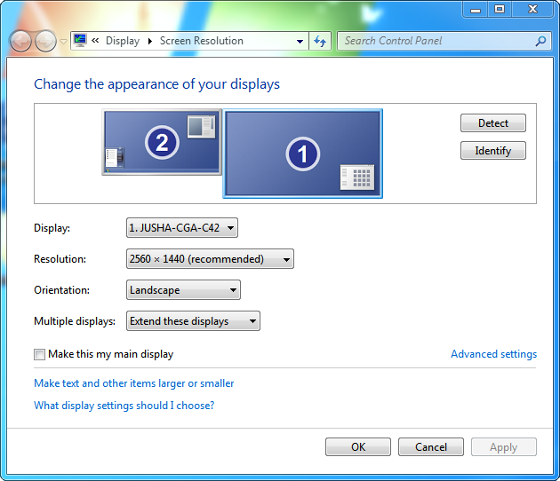

In the [Screen resolution] windows, you can:

* Change the relative logical position of the display by dragging the screen number..
* Select the display from the pull-down list, then set the resolution and direction。Choose 【Extending the Display】 from the multi-display dropdown list to enable two screens. Software windows can be freely moved between the two screens, and both screens can be operated with the mouse.
* Set main display by checking the option [Set it as my main display], which will display the task bar and desktop icons.

|  |  |
| --- | --- |
|  | **Note:**  For multi- screen extension of Windows 8/10 operating system, please refer to setting method of Windows 7. |

# Display Setting

## Start the display

To initiate the display, connect the power cord and flipthe AC power switch to “ ︳” position. The key indicator on the side of the display will illuminate red. Start the display by pressing power switch button；The power indicator will then change to green.

|  |  |
| --- | --- |
|  | **Note:**  1. The monitor features a memory function that automatically records the user’s last shutdown mode. If you turn off the monitor using the on-off button and then switch off the AC power, you will need to press the on-off buttonagain to restart after turning the AC power back. If the power is cutoff directly using the AC power switch, you can restart the power directly without needing to press the on-off button after turning the AC power back on.  2. To power off the monitor, press the AC power switch directly and wait for 4 seconds until the indicator light turns y off completely before disconnecting from the power source. |

## Shutting Down the Display

Onto turn off the display, press the power switch button while the display is on; the power indicator will turn red. Then, turn off the AC switch; power indicator will go out, and then pull off the power socket.

## Menu Description

Users can adjust the display setting using the buttons or menu functions to suit their work environment. Additionally, basic information and current settings of the display can be viewed through the menu.

The menu diagram is organized into three sections, as follows:   
1. The top section displays the signal source and the physical resolution of display.   
2. The left section displays the main menu options.   
3. The right section displays the submenu and its options.

Info: Current signal source

Prompt information : Signal resolution

Prompt: Key navigation information

Submenus and their options

Main menu

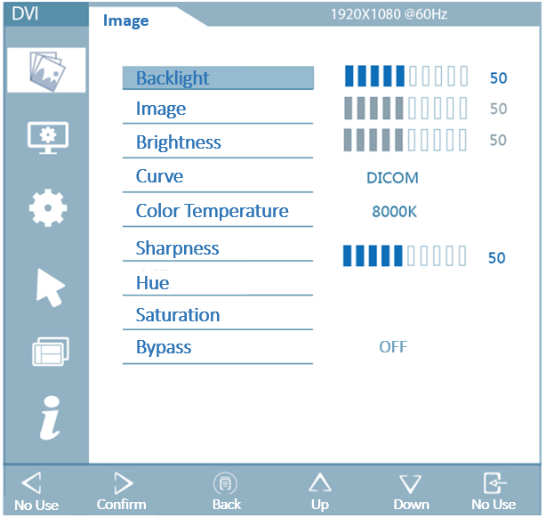

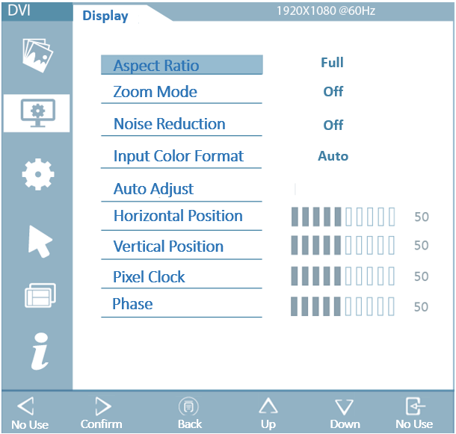 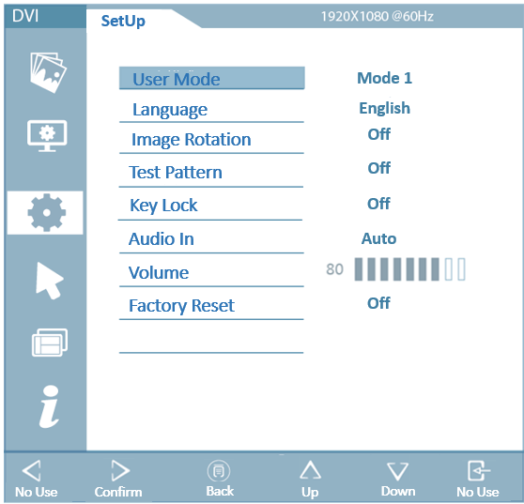 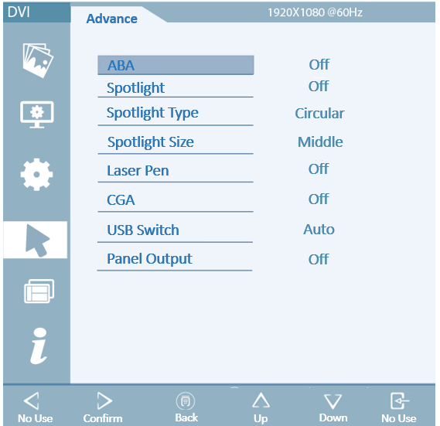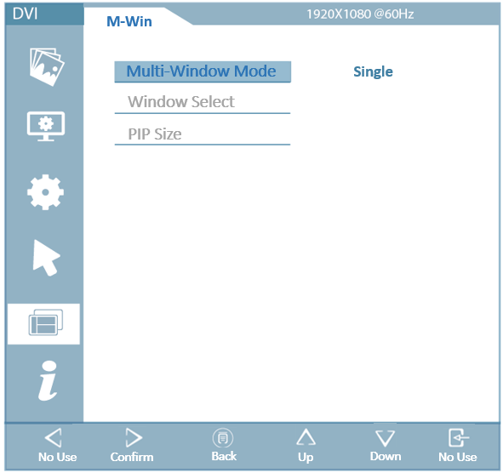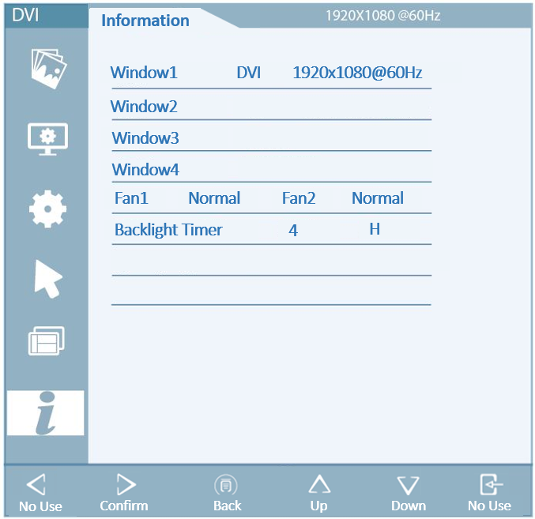

|  |  |
| --- | --- |
|  | **Note:**  The menu provided here is for illustrative purposes only, and may differ from the actual menu, as menus can vary between models. |

The specific menu options and parameters are shown below:

|  |  |  |  |
| --- | --- | --- | --- |
| **Main menu** | **Menu option** | **Parameter specification** | **Default setting** |
| IMAGE | Brightness | (Progress bar) 0~100 | 50 |
| Contrast | (Progress bar) 0~100 | 50 |
| Digital brightness | (Progress bar) 0~100 | 50 |
| Curve | DICOM | DICOM |
| GAMMA2.0 |
| GAMMA2.2 |
| CIE |
| DSA |
| Color Temperature | 6500K | 8000K |
| 8000K |
| 9300K |
| Sharpness | (Progress bar) 0~100 | 50 |
| Hue | (Progress bar) 0~100 | 50 |
| Bypass | Off | Off |
| On |
| DISPLAY | Ratio Mode | Full screen | Full screen |
| 4:3 |
| 5:4 |
| 16:9 |
| 1:1 |
| Min. proportion |
| Max. proportion |
| Zoom Mode | Off | Off |
| 5% |
| 10% |
| 15% |
| 20% |
| Noise Reduction | Off | Off |
| Low |
| Medium |
| Strong |
| Input Color Format | Auto | Auto |
| RGB |
| YPbPr |
| Auto Adjust | / | / |
| Horizontal Position | (Progress bar) 0~100 | 50 |
| Vertical Position | (Progress bar) 0~100 | 50 |
| Pixel Clock | (Progress bar) 0~100 | 50 |
| Phase | (Progress bar) 0~100 | 50 |
| SETUP | User Mode | Mode1 | Mode1 |
| Mode2 |
| Mode3 |
| Mode4 |
| Mode5 |
| Mode6 |
| Language | English | Simplified Chinese |
| Simplified Chinese |
| Image Rotation | Off | Off |
| 90 Degree |
| 180 Degree |
| 270 Degree |
| H-Mirror |
| V-Mirror |
| Test Pattern | Off | Off |
| Image 1 |
| Image 2 |
| Image 3 |
| Image 4 |
| Key Lock | Off | Off |
| On |
| Audio In | Auto | Auto |
| HDMI 1 |
| HDMI 2 |
| HDMI 3 |
| DP |
| Microphone |
| Audio Out | Built-in speaker | Built-in speaker |
| External speaker |
| Volume | (Progress bar) 0~100 | 80 |
| Factory Reset | On | Off |
| Off |
| Advance | ABA | On | Off |
| Off |
| Spotlight | On | Off |
| Off |
| Spotlight Type | Circular | Circular |
| Rectangle |
| Spotlight Size | Small | Middle |
| Middle |
| Large |
| Laser Pen | On | Off |
| Off |
| CGA | On | Off |
| Off |
| USB Switch | Auto | Auto |
| External 1 |
| External 2 |
| External 3 |
| External 4 |
| External 5 |
| External 6 |
| Internal 1 |
| Internal 2 |
| Panel Output | Off | Off |
| 1080P |
| M-Win | Multi-Window Mode | Single | Single |
| PIP |
| PBP1 |
| TXT |
| PBP2 |
| Triple |
| Quad |
| Window Select | Window 1 | Window 1 |
| Window 2 |
| Window 3 |
| Window 4 |
| All |
| PIP Size | Small | Medium |
| Medium |
| Large |
| Huge |
| Information | Working condition | (Right option)  Including temperature, backlight sensor, fan control and fan status | Used to monitor the internal working status of display |

## Operate OSD Menu

### Accessing the On-Screen Display (OSD) Menu

To access the OSD menu while the display is on, press  . The OSD menu will appear on the display. If no further action is taken within 30s, OSD menu will automatically close.

### Exiting the OSD menu

There are two methods to exit the OSD menu:

1. Within a submenu, press  to return to the previous menu level; and then press  to leave the menu.   
2. The OSD menu will close on its own if no action is taken for 30 seconds.

### Adjusting Display brightness

To adjust the display's backlight brightness:

1. Press  to open the menu and by default, [**Image**] page is appears firstly.
2. Press  to navigate to the submenu.
3. Using ****/**** to select [**Brightness**].
4. Adust the brightness by pressing the / button, on the progress bar, and set the backlight brightness value as required. Step: 1 Default value: 50

|  |  |
| --- | --- |
|  | **Note:**  LED backlight has a finite lifespan. We recommend set the brightness value to 50 to extend the display’s longevity. |

### Adjusting Contrast

To adjust the display’s contrast:

1. Press  to open the OSD menu. By default, [**Image**] page is shown firstly.
2. Press  to enter the image submenu page .
3. Press ****/**** to move cursor to [**Contrast**]. Press  to enter the contrast progress bar.
4. The user may, as necessary, set contrast value of the screen by pressing down  / to increase or decrease the value of progress bar. Step: 1 Default value: 50

### Adjust digital brightness

The operation is as follows：

1. Press  to call out menu and by default, [**Image**] page is displayed firstly.
2. Press  to enter the image submenu page.
3. Move the cursor to [**Digital Brightness**] by pressing ****/**** .
4. The user can press the / button to increase or decrease the progress bar value, and set the [**Digital Brightness**] value as required. Step: 1 Default value: 50

### Select calibration curve

The operation is as follows：

1. Press  to call out menu and by default, [**Image**] page is displayed firstly.
2. Press  to enter the image submenu page.
3. Move the cursor to [**Curve**] by pressing ****/**** .
4. Users can select different curves by pressing /.Options: GAMMA2.0, GAMMA2.2, DICOM, CIE, DSA. Default value: DICOM.

### Color temperature selection

The operation is as follows：

1. Press  to call out menu and by default, [**Image**] page is displayed firstly.
2. Press  to enter the image submenu page.
3. Move the cursor to [**Color temperature**] by pressing ****/**** .
4. Users can select different color temperature by pressing /.Options: 6500K, 8000K, 9300K. Default value: 8000K.

### Adjust sharpness

Operations are as follows:

1. Press  to call out menu and by default, [**Image**] page is displayed firstly.
2. Press  to enter the image submenu page.
3. Move the cursor to [**sharpness**] by pressing ****/**** .
4. The user can press the / button to increase or decrease the progress bar value, and set the [**Sharpness**] value as required. Step: 1 Default value: 50

### Adjust hue

Operations are as follows:

1. Press  to call out menu and by default, [**Image**] page is displayed firstly.
2. Press  to enter the image submenu page.
3. Move the cursor to [**Hue**] by pressing ****/**** .
4. The user can press the / button to increase or decrease the progress bar value, and set the [**Hue**] value as required. Step: 1 Default value: 50

### Adjust saturation

Operations are as follows:

1. Press  to call out menu and by default, [**Image**] page is displayed firstly.
2. Press  to enter the image submenu page.
3. Move the cursor to [**Saturation**] by pressing ****/**** .
4. The user can press the / button to increase or decrease the progress bar value, and set the [**Saturation**] value as required. Step: 1 Default value: 50

### Adjust bypass

Operations are as follows:

1. Press  to call out menu and by default, [**Image**] page is displayed firstly.
2. Press  to enter the image submenu page.
3. Move the cursor to [**Bypass**] by pressing ****/**** .
4. The user can turn on or off the bypass mode by pressing /. Option: On ,Off. Default value: Off

### Adjust ratio mode

Operations are as follows:

1. Press  to call out menu and by default, [**Image**] page is displayed firstly.
2. Move the cursor to [**Display**] by pressing ****/**** .
3. Press  to enter the display settings submenu interface..
4. Move the cursor to [**Aspect** **Ratio**] by pressing ****/**** .
5. Users can select different scale modes by pressing /. Options: Full screen, 4:3, 5:4, 16:9, 1:1, minimum scale, maximum scale. Default value: full screen.

### Adjust zoom mode

Operations are as follows:

1. Press  to call out menu and by default, [Image] page is displayed firstly.
2. Move the cursor to [**Display**] by pressing / .
3. Press  to enter the display settings submenu interface.
4. Move the cursor to [**Zoom Mode**] by pressing / .
5. Users can select different zoom modes by pressing /. Options: Off, 5%, 10%, 15%,20%. Default value: Off.

### Adjust noise reduction

Operations are as follows:

1. Press  to call out menu and by default, [Image] page is displayed firstly.
2. Move the cursor to [**Display**] by pressing / .
3. Press  to enter the display settings submenu interface.
4. Move the cursor to [**Noise Reduction**] by pressing / .
5. Users can select different noise reduction mode by pressing /. The options are off, Low, medium and high. Default value: off.

### Adjust input color format

Operations are as follows:

1. Press  to call out menu and by default, [Image] page is displayed firstly.
2. Move the cursor to [**Display**] by pressing / .
3. Press  to enter the display settings submenu interface.
4. Move the cursor to [**Input Color Format**] by pressing / .
5. Users can select different input color format by pressing /. Options: Auto, RGB, YPbPr. Default value: Auto.

### VGA channel image automatic adjustment

Operations are as follows:

1. Press  to call out menu and by default, [Image] page is displayed firstly.
2. Move the cursor to [**Display**] by pressing / .
3. Press  to enter the display settings submenu interface.
4. Move the cursor to [**Auto Adjust**] by pressing / .
5. The user can press / to switch the automatic adjustment switch.

### The VGA channel adjusts the horizontal position

Operations are as follows:

1. Press  to call out menu and by default, [Image] page is displayed firstly.
2. Move the cursor to [**Display**] by pressing / .
3. Press  to enter the display settings submenu interface.
4. Move the cursor to [**Horizontal Position**] by pressing / .
5. The user can press the / button to increase or decrease the progress bar value, and set the [**Horizontal Position**] value as required. Step: 1 Default value: 50

### The VGA channel adjusts the vertical position

Operations are as follows:

1. Press  to call out menu and by default, [Image] page is displayed firstly.
2. Move the cursor to [**Display**] by pressing / .
3. Press  to enter the display settings submenu interface.
4. Move the cursor to [**Vertical Position**] by pressing / .
5. The user can press the / button to increase or decrease the progress bar value, and set the [**Vertical Position**] value as required. Step: 1 Default value: 50

### VGA channel adjusts pixel clock

Operations are as follows:

1. Press  to call out menu and by default, [Image] page is displayed firstly.
2. Move the cursor to [**Display**] by pressing / .
3. Press  to enter the display settings submenu interface.
4. Move the cursor to [**Pixel Clock**] by pressing / .
5. The user can press the / button to increase or decrease the progress bar value, and set the [**Pixel Clock**] value as required. Step: 1 Default value: 50

### VGA channel adjusts the phase

Operations are as follows:

1. Press  to call out menu and by default, [Image] page is displayed firstly.
2. Move the cursor to [**Display**] by pressing / .
3. Press  to enter the display settings submenu interface.
4. Move the cursor to [**Phase**] by pressing / .
5. The user can press the / button to increase or decrease the progress bar value, and set the [**Phase**] value as required. Default value: Automatically obtain the value based on the automatic adjustment result. Adjust step: The value is automatically obtained based on the automatic adjustment result. Default value: 50.

### Adjust user mode

Operations are as follows:

1. Press  to call out menu and by default, [Image] page is displayed firstly.
2. Move the cursor to [**SetUp**] by pressing / .
3. Press  to enter the setting submenu interface.
4. Move the cursor to [**User Mode**] by pressing / .
5. Users can select different user mode by pressing /. Options: Mode 1, Mode 2, Mode 3, Mode 4, mode 5, mode 6. Default value: Mode 1.

### Adjust display language

Operations are as follows:

1. Press  to call out menu and by default, [Image] page is displayed firstly.
2. Move the cursor to [**SetUp**] by pressing / .
3. Press  to enter the setting submenu interface.
4. Move the cursor to [**Language**] by pressing / .
5. Users can select different language by pressing /. Options: English, simplified Chinese . Default value: Chinese (domestic); English (export).

### Image Rotation

Operations are as follows:

1. Press  to call out menu and by default, [Image] page is displayed firstly.
2. Move the cursor to [**SetUp**] by pressing / .
3. Press  to enter the setting submenu interface.
4. Move the cursor to [**Image Rotation**] by pressing / .
5. The user can press / to switch the screen rotation switch. Options: Off, 90 Degree, 180 Degree, 270 Degree, H-Mirror, V-Mirror. Default value: off.

### Test pattern function adjustment

Operations are as follows:

1. Press  to call out menu and by default, [Image] page is displayed firstly.
2. Move the cursor to [**SetUp**] by pressing / .
3. Press  to enter the setting submenu interface.
4. Move the cursor to [**Test Pattern**] by pressing / .
5. Users can select different test pattern by pressing /. Options: Off, Image 1, Image 2, Image 3, image 4, image 5. Default value: off.

### Key lock switch

Operations are as follows:

1. Press  to call out menu and by default, [Image] page is displayed firstly.
2. Move the cursor to [**SetUp**] by pressing / .
3. Press  to enter the setting submenu interface.
4. Move the cursor to [**Key Lock**] by pressing / .
5. The user switches the key lock by pressing /.Options: On and off. Default value: off.

### Audio input regulation

Operations are as follows:

1. Press  to call out menu and by default, [Image] page is displayed firstly.
2. Move the cursor to [**SetUp**] by pressing / .
3. Press  to enter the setting submenu interface.
4. Move the cursor to [**Audio In**] by pressing / .
5. Users can select different audio input by pressing /. Options: Auto, HDMI1, HDMI2, HDMI3, microphone. Default value: Auto.

### Audio output regulation

Operations are as follows:

1. Press  to call out menu and by default, [Image] page is displayed firstly.
2. Move the cursor to [**SetUp**] by pressing / .
3. Press  to enter the setting submenu interface.
4. Move the cursor to [**Audio Out**] by pressing / .
5. The user switches the audio output by pressing /. Options: Built-in speaker, external speaker. Default value: Built-in speaker.

### Volume control

Operations are as follows:

1. Press  to call out menu and by default, [Image] page is displayed firstly.
2. Move the cursor to [**SetUp**] by pressing / .
3. Press  to enter the setting submenu interface.
4. Move the cursor to [**Volume**] by pressing / .
5. The user can press the / button to increase or decrease the progress bar value, and set the [**Pixel Clock**] value as required. Step: 1 Default value: 80 .

### Adjust factory setting

Operations are as follows:

1. Press  to call out menu and by default, [Image] page is displayed firstly.
2. Move the cursor to [**SetUp**] by pressing / .
3. Press  to enter the setting submenu interface.
4. Move the cursor to [**Factory Reset**] by pressing / .
5. The user can press the / button to switch factory reset options .Options: On and off. Default value: off.
6. Press  to confirm the options.

### Ambient light

Operations are as follows:

1. Press  to call out menu and by default, [Image] page is displayed firstly.
2. Move the cursor to [**Advance**] by pressing / .
3. Press  to enter the advanced function submenu.
4. Move the cursor to [**ABA**] by pressing / .
5. Press / to switch the ambient light function. Options: On or off. Default value: off.

### Spotlight

Operations are as follows:

1. Press  to call out menu and by default, [Image] page is displayed firstly.
2. Move the cursor to [**Advance**] by pressing / .
3. Press  to enter the advanced function submenu.
4. Move the cursor to [**Spotlight**] by pressing / .
5. Press / to switch the spotlight function. Options: On or off. Default value: off.

### Spotlight Type

Operations are as follows:

1. Press  to call out menu and by default, [Image] page is displayed firstly.
2. Move the cursor to [**Advance**] by pressing / .
3. Press  to enter the advanced function submenu.
4. Move the cursor to [**Spotlight Type**] by pressing / .
5. Press / to switch the spotlight shape, options: circle, rectangle. Default value: circle.

### Spotlight Size

Operations are as follows:

1. Press  to call out menu and by default, [Image] page is displayed firstly.
2. Move the cursor to [**Advance**] by pressing / .
3. Press  to enter the advanced function submenu.
4. Move the cursor to [**Spotlight Size**] by pressing / .
5. Press / to switch the spotlight size. Options: Small, medium, large. Default value: medium.

### Laser Pen

Operations are as follows:

1. Press  to call out menu and by default, [Image] page is displayed firstly.
2. Move the cursor to [**Advance**] by pressing / .
3. Press  to enter the advanced function submenu.
4. Move the cursor to [**Laser Pen**] by pressing / .
5. Press / to switch the laser pen function. Options: On or off. Default value: off.

### CGA

Operations are as follows:

1. Press  to call out menu and by default, [Image] page is displayed firstly.
2. Move the cursor to [**Advance**] by pressing / .
3. Press  to enter the advanced function submenu.
4. Move the cursor to [**CGA**] by pressing / .
5. Press / to switch the CGA function. Options: On or off. Default value: off.

### USB Switch

Operations are as follows:

1. Press  to call out menu and by default, [Image] page is displayed firstly.
2. Move the cursor to [**Advance**] by pressing / .
3. Press  to enter the advanced function submenu.
4. Move the cursor to [**USB Switch**] by pressing / .
5. Press / to switch the USB switch function. Options: Automatic selection, external USB1, external USB2, external USB3, external USB4, external USB5, external USB6, built-in USB1, built-in USB2. Default value: Automatic selection.

### Panel Output

Operations are as follows:

1. Press  to call out menu and by default, [Image] page is displayed firstly.
2. Move the cursor to [**Advance**] by pressing / .
3. Press  to enter the advanced function submenu.
4. Move the cursor to [**Panel Output**] by pressing / .
5. Press / to switch the panel output function. Options: Off, 1080p. Default value: off.

### Multi-window mode

Operations are as follows:

1. Press  to call out menu and by default, [Image] page is displayed firstly.
2. Move the cursor to [**M-Win**] by pressing / .
3. Press  to enter the multi-window settings submenu interface.
4. Move the cursor to [**Multi-Window Mode**] by pressing / .
5. Press / to switch the multi-window mode function. Options: Single, PIP, PBP1, TXT, PBP2,Triple, Quad. Default value: Single.

### Window Select

Operations are as follows:

1. Press  to call out menu and by default, [Image] page is displayed firstly.
2. Move the cursor to [**M-Win**] by pressing / .
3. Press  to enter the multi-window settings submenu interface.
4. Move the cursor to [**Window Select**] by pressing / .
5. Press / to switch the window select function. Options: Windows 1, Windows 2, Windows 3, Windows 4, All Windows. Default value: Windows 1.

### PIP Size

Operations are as follows:

1. Press  to call out menu and by default, [Image] page is displayed firstly.
2. Move the cursor to [**M-Win**] by pressing / .
3. Press  to enter the multi-window settings submenu interface.
4. Move the cursor to [**PIP Size**] by pressing / .
5. Press / to switch the PIP size function. Options: Options: Small, medium, Large, Huge. Default value: medium

## Signal source selection

Operations are as follows:

1. Press  to bring up the signal source menu.
2. Select different Windows by pressing / .
3. Press / to switch the signal source. Options: DVI1, DVI2, DVI3, DVI4, HDMI1, HDMI2, OPS1,OPS2,DP,VGA.
4. Press  to confirm the selected source channel.

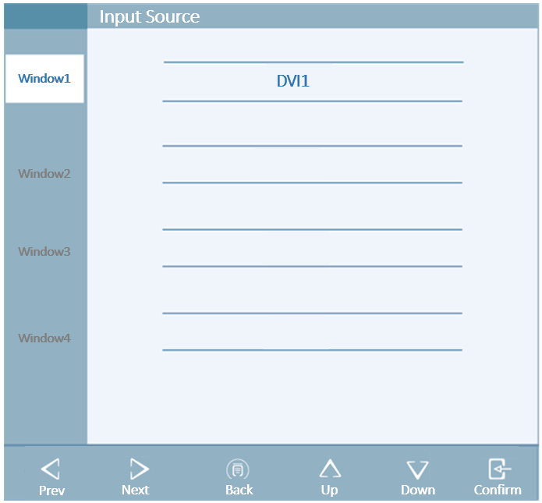

## Prompt information menu

If the display is in certain state, the display center will display a prompt information menu to inform the user of the current state of the display, so that the user can operate the display conveniently.

|  |  |  |
| --- | --- | --- |
| **Reminder** | | **Description** |
|  | No input signal | When the energy saving mode is enabled and no signal is input, XX No signal is displayed (XX is the current signal source channel). The prompt keeps floating in the screen (changing the display position) until there is an input signal does not disappear immediately; When the energy saving mode is enabled, the message "Enter power saving mode after 5 minutes without XX cable" (XX is the current selected channel) is displayed. The message does not disappear until there is an input signal or the energy saving mode is entered after 5 minutes. |
|  | Input port | Display the current signal channel on the screen after switching channels (top right corner of the screen) |
|  | Input resolution information | Prompt resolution information on the screen after the screen is lit (top right corner of the screen) |
|  | Shortcut key | Enabling or disenabling prompt for shortcut key function |

# Important information

## Technical specification

### S9820

|  |  |
| --- | --- |
| Input voltage | AC 100V~240V；50Hz/60Hz±5% |
| Rated power（Max.） | 600W |
| LCD | 98 inch，TFT color LCD |
| Luminance | Typical brightness:500cd/m²  Maximum calibrated brightness: 450cd/m² |
| Visual angle | Horizontal 178°,vertical 178° （CR＞10） |
| Native resolution | 3840×2160 |
| Input interface | HDMI×2,DP×1,DVI×4,VGA×1 |
| Output interface | HDMI×1,DP×1 |
| Audio input interface | DP×1,HDMI×2,3.5mm Mic×1,3.5mm Line×2 |
| Audio output interface | 3.5mm Line×2,3.5mm IIS×1 |
| Built-in speaker | 10W×2 |
| Additional function | Wireless remote control, infrared touch |
| Operating environment | Temperature: 0℃~40℃  Humidity: 20%~85%（Non condensation）  Air pressure: 700hPa~1060hPa |
| Storage environment | Temperature: -20℃~60℃  Humidity: 20%~85% Non condensation  Air pressure: 700hPa~1060hPa |
| Certification | CCC,CE |

## Environmental protection information

The product’s raw material conforms to RoHS requirement, ensuring they are free from hazardous substances such as lead, mercury, etc.

## Safety standard

Safety standards for S9820：

|  |  |
| --- | --- |
| The Medical Display Safety standards | IEC 60601‑1: 2012.  EN 60601-1:2013  GB4943.1-2022 |

## Electromagnetic compatibility

The product’s electromagnetic compatibility conforms to the following conditions:

|  |  |
| --- | --- |
| Electromagnetic interference | GB17625.1-2022  GB/T9254.1-2021  IEC 60601 1-2: 2014.  EN 60601-1-2:2015 |

## Guidance and Manufacturer’s Declaration

Below cables information are provided for EMC reference.

|  |  |  |  |  |
| --- | --- | --- | --- | --- |
| **Cable** | **Max. cable length,**  **Shielded/unshielded** | | **Number** | **Cable classification** |
| AC Power Line | 5m | Unshielded | 1 Set | AC Power |
| DVI Cable | 5m | shielded | 1 Set | DC Power |
| DP Cable | 5m | shielded | 1 Set | DC Power |
| HDMI Cable | 5m | shielded | 1 Set | DC Power |
| HDMI Cable | 10m | shielded | 1 Set | DC Power |
| USB Cable | 5m | shielded | 1 Set | DC Power |

**Important information regarding Electro Magnetic Compatibility (EMC)**

This electrical medical equipment needs special precautions regarding EMC and put into service according to the EMC information provided in the user manual , The equipment conforms to this IEC 60601-1-2:2014 standard for both immunity and emissions. Nevertheless, special precautions need to be observed:

The equipment with no ESSENTIAL PERFORMANCE is intended used in Professional healthcare facility environment except for near active HF SURGICAL EQUIPMENT and the RF shielded room of an ME SYSTEM for magnetic resonance imaging, where the intensity of EM DISTURBANCES is high.

WARNING: Use of this equipment adjacent to or stacked with other equipment should be avoided because it could result in improper operation. If such use is necessary, this equipment and the other equipment should be observed to verify that they are operating normally.

The use of accessories and cables other than those specified or provided by the manufacturer of this equipment could result in increased electromagnetic emissions or decreased electromagnetic immunity of this equipment and result in improper operation.

WARNING: Portable RF communications equipment (including peripherals such as antenna cables and external antennas) should be used no closer than 30 cm (12 inches) to any part of the S9820, including cables specified by the manufacturer. Otherwise, degradation of the performance of this equipment could result.

When the AC input voltage is interrupted, the equipment will shut down and if the power supply restored, it should be recovered by operator manually, this degradation could be accepted because it will not lead to unacceptable risks and it will not result in the loss of basic safety or essential performance.

**EMI Compliance Table (Table 1)**

**Table 1 - Emission**

|  |  |  |
| --- | --- | --- |
| **Phenomenon** | **Compliance** | **Electromagnetic environment** |
| RF emissions | CISPR 11  Group 1, Class A | Professional healthcare facility environment |
| Harmonic distortion | IEC 61000-3-2  Class A | Professional healthcare facility environment |
| Voltage fluctuations and flicker | IEC 61000-3-3  Compliance | Professional healthcare facility environment |

**NOTE** The EMISSIONS characteristics of this equipment make it suitable for use in industrial areas and hospitals (CISPR 11 class A). If it is used in a residential environment (for which CISPR 11 class B is normally required) this equipment might not offer adequate protection to radio-frequency communication services. The user might need to take mitigation measures, such as relocating or re-orienting the equipment.

**EMS Compliance Table (Table 2-5)**

**Table 2 - Enclosure Port**

|  |  |  |
| --- | --- | --- |
| **Phenomenon** | **Basic EMC standard** | **Immunity test levels** |
| **Professional healthcare facility environment** |
| Electrostatic Discharge | IEC 61000-4-2 | ±8 kV contact  ±2kV, ±4kV, ±8kV, ±15kV air |
| Radiated RF EM field | IEC 61000-4-3 | 3V/m  80MHz-2.7GHz  80% AM at 1kHz |
| Proximity fields from RF wireless communications equipment | IEC 61000-4-3 | Refer to table 3 |
| Rated power frequency magnetic fields | IEC 61000-4-8 | 30A/m  50Hz or 60Hz |

**Table 3 – Proximity fields from RF wireless communications equipment**

|  |  |  |
| --- | --- | --- |
| **Test frequency**  **(MHz)** | **Band**  **(MHz)** | **Immunity test levels** |
| **Professional healthcare facility environment** |
| 385 | 380-390 | Pulse modulation 18Hz, 27V/m |
| 450 | 430-470 | FM, ±5kHz deviation, 1kHz sine, 28V/m |
| 710 | 704-787 | Pulse modulation 217Hz, 9V/m |
| 745 |
| 780 |
| 810 | 800-960 | Pulse modulation 18Hz, 28V/m |
| 870 |
| 930 |
| 1720 | 1700-1990 | Pulse modulation 217Hz, 28V/m |
| 1845 |
| 1970 |
| 2450 | 2400-2570 | Pulse modulation 217Hz, 28V/m |
| 5240 | 5100-5800 | Pulse modulation 217Hz, 9V/m |
| 5500 |
| 5785 |

**Table 4 – Input a.c. power Port**

|  |  |  |
| --- | --- | --- |
| **Phenomenon** | **Basic EMC standard** | **Immunity test levels** |
| **Professional healthcare facility environment** |
| Electrical fast transients/burst | IEC 61000-4-4 | ±2 kV  100kHz repetition frequency |
| Surges Line-to-line | IEC 61000-4-5 | ±0.5 kV, ±1 kV |
| Surges Line-to-ground | IEC 61000-4-5 | ±0.5 kV, ±1 kV, ±2 kV |
| Conducted disturbances induced by RF fields | IEC 61000-4-6 | 3V, 0.15MHz-80MHz  6V in ISM bands between 0.15MHz and 80MHz  80%AM at 1kHz |
| Voltage dips | IEC 61000-4-11 | 0% UT; 0.5 cycle  At 0º, 45º, 90º, 135º, 180º, 225º, 270º and 315º |
| 0% UT; 1 cycle  and  70% UT; 25/30 cycles  Single phase: at 0º |
| Voltage interruptions | IEC 61000-4-11 | 0% UT; 250/300 cycles |

**Table 5 – Signal input/output parts Port**

|  |  |  |
| --- | --- | --- |
| **Phenomenon** | **Basic EMC standard** | **Immunity test levels** |
| **Professional healthcare facility environment** |
| Electrical fast transients/burst | IEC 61000-4-4 | ±1 kV  100kHz repetition frequency |
| Conducted disturbances induced by RF fields | IEC 61000-4-6 | 3V, 0.15MHz-80MHz  6V in ISM bands between 0.15MHz and 80MHz  80%AM at 1kHz |

# Statement

## Legal Statement

The auxiliary equipment connected to the display shall be certified by the corresponding IEC standard (data processing equipment shall conform to IEC 60950-1 standard, and medical equipment IEC 60601-1). In addition, all configurations shall conform to IEC 60601-1-1. Anyone who connects other devices to a signal output or input interface for system configuration must ensure that the system conforms to IEC 60601-1 -1.

 The worker responsible for connecting the display to the system must ensure that the equipment installed conforms to IEC 60601-1-1. In case of doubt, please contact in time the Technical Service Department or the local sales representative of Nanjing Jusha Display Technology Co., Ltd.

Nanjing Jusha Display Technology Co., Ltd. sells products through other medical equipment manufacturers, distributors and dealers and, while purchasing the product, it is required to consult the seller if corresponding product maintenance service is provided.

Nanjing Jusha Display Technology Co., Ltd. shall not bear or authorize anyone to bear any responsibility for the sale or use of the products. In order to ensure the correct use and maintenance of the products of Nanjing Jusha Display Technology Co., Ltd., please refer to relevant documents and user manual of the product or the label on the product and on the package.

Please be noted that the system configuration, software, applications, customer data, and the operational control of the system will affect the performance of product. Although our products are compatible with many systems, the specific functional realization by customers will be different. If the product is suitable for a specific purpose or the application is determined by the customer, Nanjing Jusha Display Technology Co., Ltd. will not guarantee it.

In particular, Nanjing Jusha Display Technology Co., Ltd. denies any form of warranty, whether express, implied and/or legal, including but not limited to any guarantee for the applicability, fitness and/or for a particular purpose, as well as for any infringement upon JUSHA product or service. We hereby expressly exclude and deny any warranty, representation and/or guarantee of any kind, nature or degree, whether implied, express and /or it causes or results in any law, statute, commercial practice, custom, trade related problems or otherwise.

Nanjing Jusha Display Technology Co., Ltd., and/or its distributors and/or dealers have no direct or indirect responsibility for any damage caused by the following factors: the damage caused by any special, accidental, indirect, punitive, disciplinary or indirect causes, including but not limited to shipment delay, delivery failure, product failure, product design or production, inability to use these products and services, future business losses or loss of profits, or other reason; any responsibility related to or arising from the purchase, sale, leasing, renting, installation, or use of products of Nanjing Jusha Display Technology Co., Ltd. These terms and conditions, or any terms relating to the composition of these terms and conditions shall be observed.

The restrictions and/or exclusions described herein may or may not apply to certain jurisdictions that do not allow exclusions, special provisions or liability limitations. In that case, the liability would be limited to the maximum extent permitted by the law of the jurisdiction.

All information contained in this User Manual, including all designs and related materials, is owned by Nanjing Jusha Display Technology Co., Ltd., and the Company shall retain all patents, copyrights and other proprietary rights to the manual. Without the explicit authorization of Nanjing Jusha Display Technology Co., Ltd., it is forbidden to plagiarize the product design, or duplicate, use and sell the product.

## Maintenance Statement

Nanjing Jusha Display Technology Co., Ltd. guarantees to provide free repair for part damage and other problems arising from production technology conforming to repair conditions within three years since the purchase date.

The quality warranty shall only apply to the products provided by Nanjing Jusha Display Technology Co., Ltd., and the products with problems arising from the equipment of other third party shall not fall within the scope of warranty.

|  |  |
| --- | --- |
|  | **Note:**  Before returning equipment to Nanjing Jusha Display Technology Co., Ltd. for repair, it is required to contact and obtain permission of Nanjing Jusha Display Technology Co., Ltd. in advance. |

**Please keep well the original package and, if the product is transported again, the original package must be selected. No heavy load on the package is permitted during transportation.**

The user shall not maintain or repair products at a place other than the after- sale service point of Nanjing Jusha Display Technology Co., Ltd., the original equipment number shall not be modified or removed. In order to obtain this quality assurance, the use shall not be contrary to the requirements of this manual, and the quality assurance will fail in such cases.

This product provides limited liability quality assurance. **Nanjing Jusha Display Technology Co., Ltd. is not responsible for the direct, indirect and accidental damage caused by the users themselves.**Users should pay attention to the system settings, software, application programs, user data and operation control of the product. All of the above factors will affect the performance of product. This product can be compatible with many systems, and users may decide to use the characteristics and functions of this product in their own discretion.

## Statement of Ownership

Nanjing Jusha Display Technology Co., Ltd. reserves all patents, copyrights and other ownership of the User Manual. Without the explicit authorization of Nanjing Jusha Display Technology Co., Ltd., it is forbidden to plagiarize the product design, or duplicate, use and sell the product.

# Contact information

Nanjing Jusha Display Technology Co., Ltd.

TEL：025-83305050

FAX：025-58783273

Free hotline：400-820-0556 800-820-0556

Address: 8A,Block 1,Nanjing International Service Outsourcing Mansion No.301, Hanzhongmen Street, Nanjing, Jiangsu, China

Website：cn.jusha.com.cn