

**JUSHA Operating Room Composite Display**

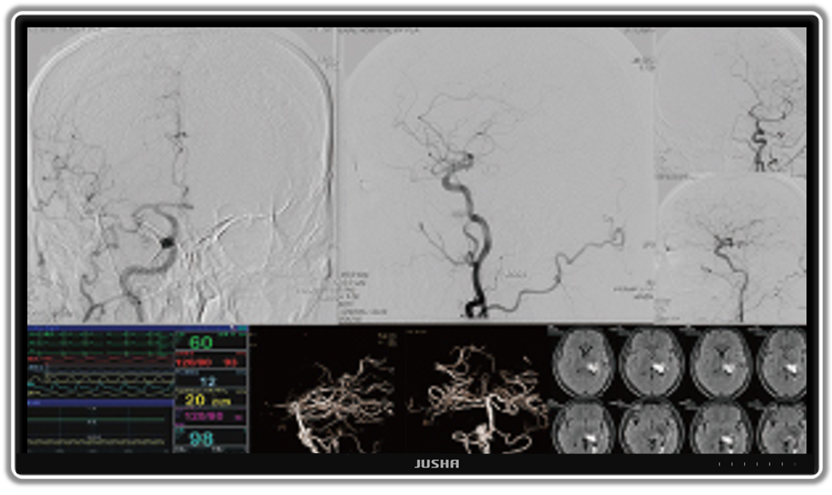

**E550EG**

**User Manual**

**Nanjing Jusha Display Technology Co., Ltd.**

Address: 8A,Block 1,Nanjing International Service Outsourcing Mansion No.301, Hanzhongmen Street, Nanjing, Jiangsu, China

TEL：025-83305050

FAX: 025-58783273

Free Hotline: 400-820-0556 800-820-0556

Website: cn.jusha.com.cn

©All rights reserved! Nanjing Jusha Display Technology Co., Ltd. 2024

Published by Nanjing Jusha Display Technology Co., Ltd.

**Contents**

1. Operating guide 1

1.1 About the Manual 1

1.2 Sign and Symbol Description 1

1.3 Safety Information 2

2. Product introduction 5

2.1 Packing list 5

2.2 Front view of display and keys 6

2.3 Rear view of display and its interfaces 7

3. Display Installation 9

4. Display Setting 12

4.1 Turn on the display 12

4.2 Sleep monitor 12

4.3 Turn off the display 12

4.4 Menu introduction 13

4.5 Operating OSD menu 17

4.5.1 Outbound menu 17

4.5.2 Exit menu 17

4.5.3 Unlock menu 17

4.5.4 Adjust backlight brightness 17

4.5.5 Adjust contrast 18

4.5.6 Adjust digital brightness 18

4.5.7 Select curve 18

4.5.8 Adjust color temperature 19

4.5.9 Adjust sharpness 19

4.5.10 Adjust tone 19

4.5.11 Adjust saturation 20

4.5.12 Adjust user mode 20

4.5.13 Adjust aspect ratio 20

4.5.14 Adjust zoom mode 21

4.5.15 Adjust noise reduction 21

4.5.16 Adjust the color format 21

4.5.17 Adjust RGB range 22

4.5.18 Adjust bypass mode 22

4.5.19 Set language 22

4.5.20 Adjust mirror image 23

4.5.21 Adjust menu lock 23

4.5.22 Adjust factory reset 23

4.5.23 Adjust emergency passage 24

4.5.24 Adjust buzzer 24

4.5.25 Adjust XFV function 24

4.5.26 Adjust multi-window mode 25

4.5.27 Select window 25

4.5.28 Adjust PIP size 25

4.5.29 Adjust PIP position 26

4.6 Shortcut key 26

4.6.1 Unlock key 26

4.6.2 Color temperature shortcut key 27

4.6.3 Curved shortcut key 28

4.6.4 Backlight brightness shortcut key (the XFV function is off) 28

4.6.5 XFV shortcut key (the XFV function is on) 29

4.6.6 Multiple window shortcut keys 29

4.6.7 Signal source shortcut key 30

4.7 Video Fusion Control 31

5. Important information 32

5.1 Technical specification 32

5.2 Environmental protection information 32

5.3 Safety standard 33

5.4 Electromagnetic compatibility 33

5.5 Guidance and Manufacturer’s Declaration 33

6. Statement 37

6.1 Legal Statement 37

6.2 Maintenance Statement 38

6.3 Statement of Ownership 39

7. Contact information 40

# Operating guide

## About the Manual

The manual is intended to guide the user in correctly installing, setting up, and operating the professional display for JUSHA grayscale and color auto-calibration group consultation and JUSHA integrated grayscale and color auto-calibration group consultation. Please read this manual carefully before use.

* This product has different specifications. Refer to the corresponding sections of the manual.
* When transferring the product to any third party, it must be accompanied by the manual.
* The product specifications are subject to change without prior notice.
* If there are any other questions about this manual, please contact Nanjing Jusha Display Technology Co., Ltd.

## Sign and Symbol Description

The following signs and symbols are used in the manual and for the product:

|  |  |
| --- | --- |
|  | Annotation information: provide more detailed information for the said object. |
|  | Warning information that prompt user of the possible hazard. |
|  | Hazardous voltage: the warning information that prompt user of the possible electric shock. |
|  | No operating. |
|  | Safe grounding |
|  | * Product conforms to China CCC certification. |
|  | **\*** Product conforms to Part 15 in FCC rules. |
|  | **\*** Product conforms to EN universal standard (certified as per medical device standard) |
|  | *Product can be sold on the North America market. |
|  | European Authorized Representative. |
|  | Users are recommended to treat the recycled product in accordance with WEEE (EU 2002/96/EC Directive, involving the treatment and recycling of waste electrical and electronic equipment). |
|  | Users are recommended to operate with reference to the manual. |
|  | Manufacturer. |
|  | Jusha product LOGO. |
| SN | Product serial number. |

* The display will conform to corresponding certification standard only when the provided power supply is used.

## Safety Information

|  |  |
| --- | --- |
|  | **Note:**  Before installing and operating the display , please read all important safety information. In case of any problem, please contact Nanjing Jusha Display Technology Co., Ltd. (025-83305050). |

**Installation environment**

* Please install the equipment near a convenient power socket.
* Do not use in an environment with a mixture of flammable anesthetic, air, oxygen or nitrous oxide, as it may cause an explosion.
* Do not expose the equipment to rain or damp; never use the display near the water source.
* When installing the base, maintain a minimum distance from the other equipment and the wall. Ensure the side and back of the medical display, when installed, are at least 10 cm away from the wall or 15 cm away from the other equipment. Pay special attention to protecting the panel surface from mechanical impact. For non-fixed installations, ensure they do not pose a safety risk to people or equipment.
* Electromagnetic interference generated by power supply equipment may affect and limit the actual performance of the product, possibly causing product failure. Install this display in an environment with controlled EMI (electromagnetic interference).
* Keep small objects or liquids away from the equipment. If small objects or liquids flow into the equipment, disconnect the power plug immediately and contact our professional maintenance personnel.

**Power Supply and Grounding**

* The disconnecting device for this product is the appliance input socket, located at the lower left of the product’s back. When S9810/S9820 is not in use, please unplug the power cord from the S9810/S9820 through the appliance input socket. Ensure that no other objects are placed near the appliance input socket, to avoid accidentally disconnecting the S9810/S9820 from the power supply.
* Always use the power cord provided with the equipment. Fully insert the power plug into the socket and ensure good contact.
* Do not touch the power cord, insert or pull it out during lightning, as it may cause electric.
* If the power cord needs to be disconnected, grasp the power plug and pull it out. Pulling the power cord may damage the power line and result in electric shock.
* Pay attention to the power supply load capacity, as circuit overload may lead to fire or electric shock.
* Use the correct voltage specified in this manual. Failure to meet the voltage requirements may cause fire, electric shock or equipment damage.
* If the device will not be used for an extended period, disconnect it from the power socket.
* If complete power supply disconnection is necessary, disconnect it from the power socket.
* Ensure that the equipment is properly connected to the required computer or other equipment.
* The equipment must be connected to a protective ground.

**Repair and Maintenance**

* Using malfunctioned equipment may result in fire, electric shock, or equipment damage. If the equipment starts to smoke, emits a scorching smell, or making unusual noise, immediately cut off the power, and contact Nanjing Jusha Display Technology Co., Ltd. for assistance.
* The maintenance must be carried out by qualified personnel. Do not attempt to repair or modify the equipment by yourself, as it may cause equipment damage or personal injury.
* Leaked liquid crystal from the liquid crystal display can have toxic and harmful effects. Avoid contact the damaged liquid crystal display. In case of contact with liquid crystal, clean it thoroughly and consult a doctor immediately.

**Application Suggestions**

* For extremely critical applications, we strongly recommend keeping spare displays available for replacement at any time.
* Avoide squeezing or pressing the display screen to prevent screen damage.
* Do not use sharp objects, such as a pencil or pen, to draw or press on the screen, as it may damage the display. Clean the screen with a clean and soft cloth.
* Avoid direct contact the signal port of the display to prevent potential electrostatic hazards.
* LCD backlight has a certain service life. We strongly recommend using the recommended brightness settings to maximize its lifespan, cand turning off the display when not in use.
* The disposal of waste equipment shall comply with local regulations.
* If the display is not being used correctly, it may interfere with other devices. It is recommended to resolve interference by:
  + Moving or adjusting the affected devices.
  + Installing partition between equipment.
  + Plugging the two devices into different power sockets.

|  |  |
| --- | --- |
|  | **Note:**  Indoor use only! |

# Product introduction

Thank you for choosing the JUSHA Operating Room Composite Display.

The E550E monitor is a high-quality image and video display instrument customized for operating room, ICU and other medical environments.

## Packing list

The packaging box for JUSHA Operating Room Composite Display may include the following items:

* 55’’ Display
* AC Power Cord
* DVI cable/ HDMI cable/ SDI cable (optional according to customer requirements)
* User manual
* Packing list
* Work gloves

|  |  |
| --- | --- |
|  | **Note:**   1. The packing list provided here is for reference only, and is subject to the one contained in the packing box. 2. In the event of damage or loss of any accessory listed in the packing list, please contact us without hesitation. 3. Never use the accessories from third parties, such as the power adaptor and graphics card. Nanjing Jusha Display Technology Co., Ltd. will not be responsible for any technical problems caused by third-party accessories. 4. Please ensure that the original packaging is kept in good condition. If the product needs to be transported again, the original package must be used. |

|  |  |
| --- | --- |
|  | **Note:**  E550E、E550E0、E550E1、E550EG、E550E*****、JUSHA-E550E、JUSHA-E550E0、JUSHA-E550E1、JUSHA-E550EG、JUSHA-E550E***** ("*"=0-9, A-Z or blank means different customers and sales markets, which does not affect safety and EMC), product information, corresponding operation Settings and specifications can be referred to S9820. |

## Front view of display and keys

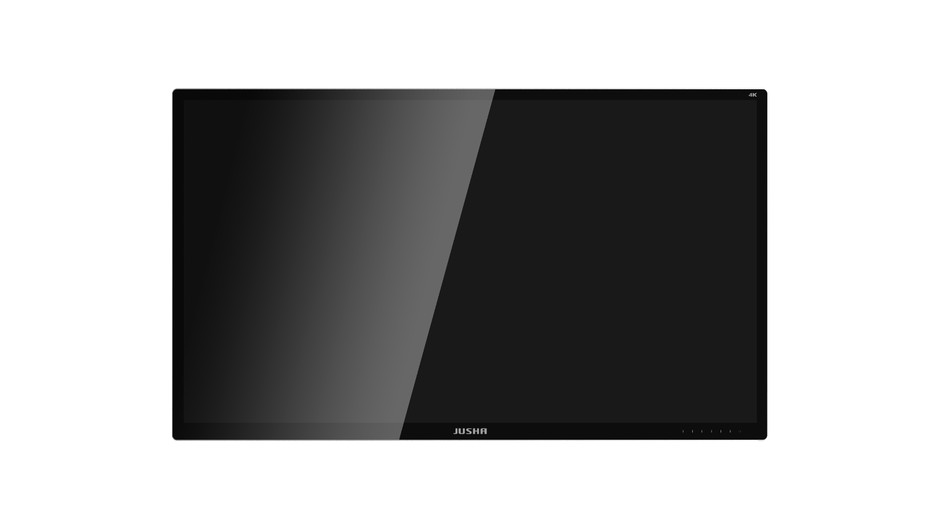

Figure 2.1 Front view of monitor

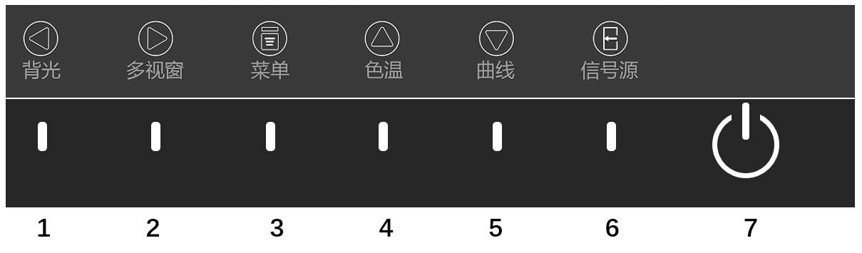

Figure 2.2 Front key

|  |  |  |
| --- | --- | --- |
| **Keys** | | **Functions** |
| ➊ | Left arrow key | Reduce the menu option value. |
| ➋ | Right arrow key | Increase the value of menu options or enter the next level menu. |
| ➌ | menu | Open or Exit the user menu. |
| ➍ | Up arrow key | Select the previous menu item. |
| ➎ | Down arrow key | Select the next menu item. |
| ➏ | Signal source selection key | Select input signal source |
| **➐** | Power button | Indicates the working status of the display.   * + 1. When the light is green, the display is normally powered on.     2. When the light is orange, the display is sleeping. |

## Rear view of display and its interfaces

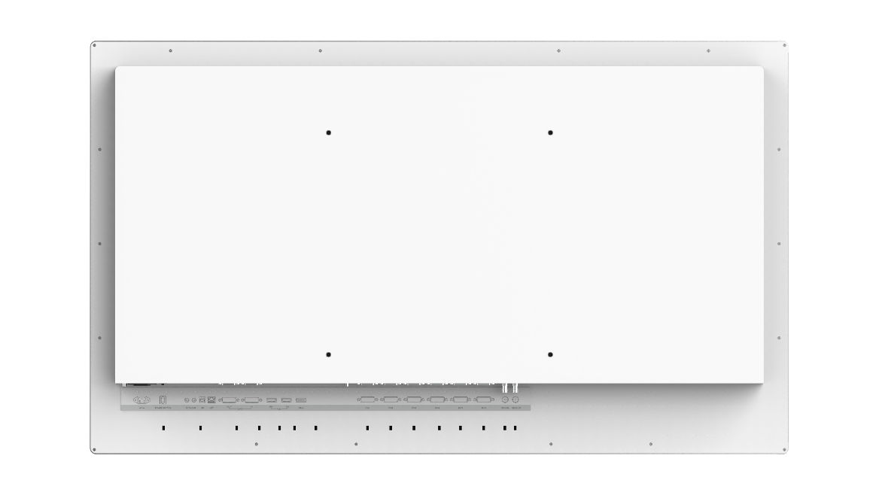



1 2 3 4 5 6 7 8 9 10

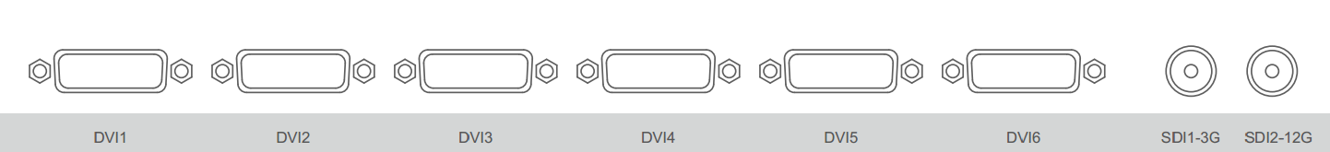

11 12 13 14 15 16 17 18

Figure 2.2 Back view of monitor and interface

**Signal interface of display and corresponding specification**

|  |  |  |
| --- | --- | --- |
| **No.** | **Signal interface** | **Specification** |
| 1 | AC-IN | AC power input interface |
| 2 | POWER SWITCH | Ship type switch |
| 3 | DC 5V-OUT | Power output interface |
| 4 | ISP | Program upgrade interface |
| 5 | NET | Communication control interface |
| 6 | DVI7 OUT | DVI output interface |
| 7 | DVI7 IN | DVI input interface |
| 8 | HDMI IN1 | 1.4 HDMI1.4 input interface |
| 9 | HDMI IN2 | 2.0 HDMI2.0 input interface |
| 10 | DP-IN | DP input interface |
| 11 | DVI1 | DVI input interface |
| 12 | DVI2 | DVI input interface |
| 13 | DVI3 | DVI input interface |
| 14 | DVI4 | DVI input interface |
| 15 | DVI5 | DVI input interface |
| 16 | DVI6 | DVI input interface |
| 17 | SDI1-3G | 3G-SDI input interface |
| 18 | SDI2-12G | 12G-SDI input interface |

# Display Installation

|  |  |
| --- | --- |
|  | **Note:**   * 1. Make sure the endoscope host and monitor are turned off.   2. After opening the packing box, please check according to the "Packing List". After confirming that the display and accessories are complete and undamaged, install the display according to the following requirements and methods. |

1. Insert one end of the signal line into the interface on the back of the monitor and the other end into the interface of the endoscope host. Tighten the screws. This product only supports wall embedding.
2. Connect the monitor to the grounding system of the operating room through the PE grounding stud at the back of the monitor.
3. Plug one end of the power cord into the socket and the other end into the monitor.
4. Open the ship type power switch.

Some important information may be useful for installation:

|  |  |  |
| --- | --- | --- |
| **No.** | **Item** | **Specification** |
| 1 | Monitor Weight | 34Kg |
| 2 | VESA | 400×400mm，M8×20 |
| 3 | External dimensions | 1261.4×745.7×79.5mm |

|  |  |
| --- | --- |
|  | **Warning:**   1. Please refer to the power cable shown in the following table to connect the adapter. If the power cord does not match the product, please contact the supplier. To avoid accidents, please use a recognized power cord that matches the voltage of the power outlet and meets the national safety standards. 2. To avoid the danger of electric shock, the power cord must be connected to the grounded power supply. 3. Power cord: When the used voltage exceeds 120 volts, the display should be powered by the center tap circuit. In addition, monitors use different types of power cord plugs in different countries, as shown in the following table. |

|  |  |  |  |
| --- | --- | --- | --- |
| District/Nation | USA, Canada | EU (exception for UK) | UK |
| Plug type |  |  |  |
| Standard | ANSI/UL 817 CSA-C22.2 No.21 | DIN VDE 0620-1:2010 | BS1363/BS546 |
| Voltage | 120V | 230V | 230V |
| District/Nation | Brazil | Japan | South Korea |
| Plug type |  |  |  |
| Standard | NBR14136 | JIS 8303 | KSC8305:2002R |
| Voltage | 220V | 110V | 220V |
| District/Nation | Denmark | Singapore | China |
| Plug type |  |  |  |
| Standard | SB 107-2-D1 | SS145 | GB15934-2008 |
| Voltage | 230V | 230V | 220V |

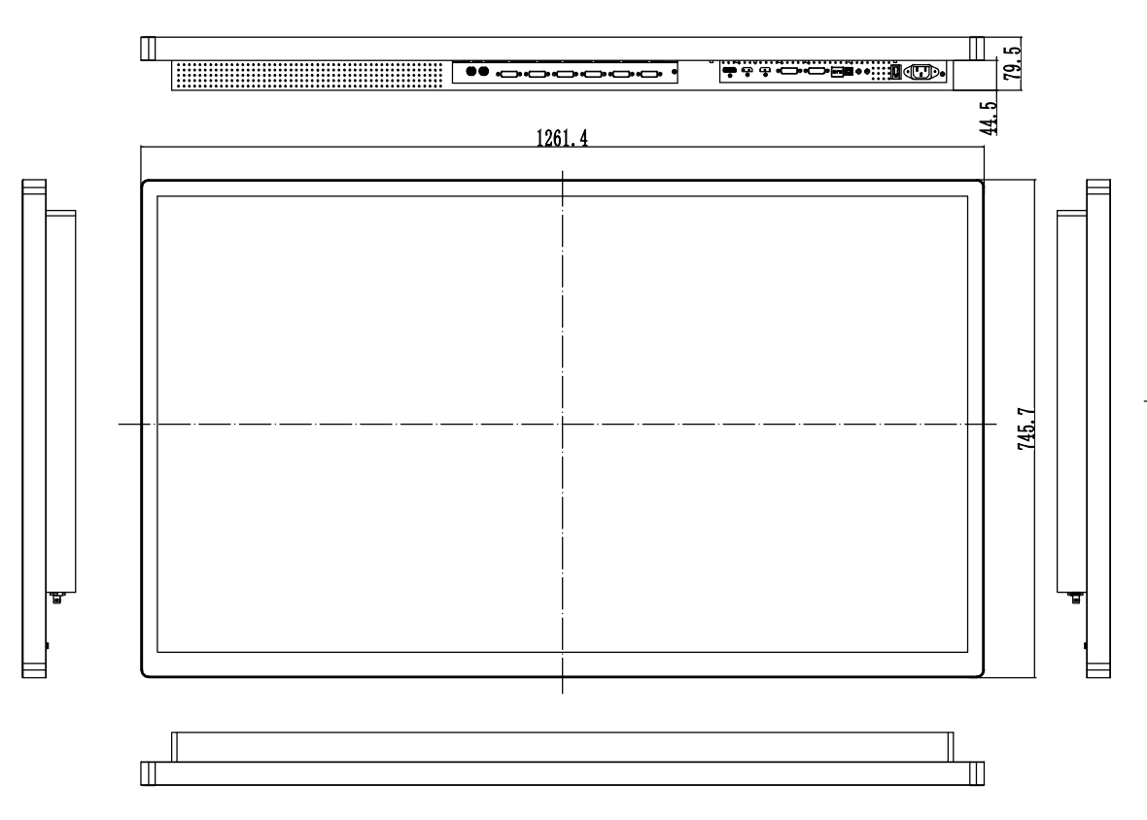

Figure 3.1 Monitor External dimensions, Front view (unit: mm）

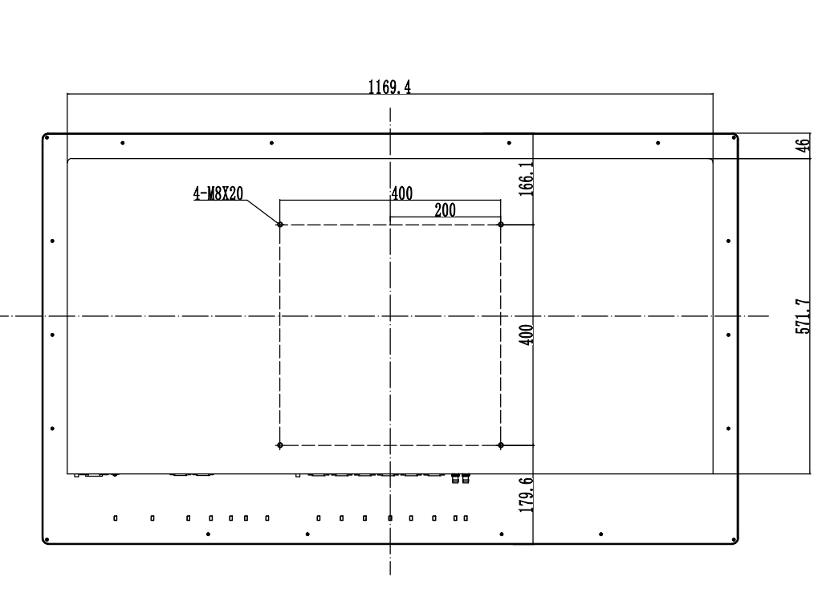

Figure 3.2 Monitor External dimensions, Back view (unit: mm）

# Display Setting

## Turn on the display

Connect the power cord and turn the power switch to " | ". When the power key indicator on the front of the monitor is pressed and the monitor is turned on, the power indicator will turn white (if it is orange, please press the power button). At the same time, the startup screen of the JUSHA will appear on the screen of the monitor, which indicates that the monitor is running..

|  |  |
| --- | --- |
|  | **Note:**  1. The monitor features a memory function that automatically records the user’s last shutdown mode. If you turn off the monitor using the on-off button and then switch off the AC power, you will need to press the on-off buttonagain to restart after turning the AC power back. If the power is cutoff directly using the AC power switch, you can restart the power directly without needing to press the on-off button after turning the AC power back on.  2. To power off the monitor, press the AC power switch directly and wait for 4 seconds until the indicator light turns off completely before disconnecting from the power source. |

## Sleep monitor

When the monitor is running, press the monitor power key, the power indicator will turn orange, the monitor has no picture, and the backlight is turned off, which indicates that the monitor is sleeping. At this time, press the power button of the monitor, the power indicator will turn white, and the startup screen of the JUSHA will appear on the monitor screen, which indicates that the monitor is running again.

## Turn off the display

Turn the AC power switch to "O", and then unplug the power cord.

## Menu introduction

By using the buttons or menu functions on the product, users can set the product in different ways to meet the needs of users' working environment. Users can view the basic information and current settings of the product through the menu. The menu is shown below and can be divided into three parts:

1. The top column shows the signal source and the physical resolution of the display.

2. The icon on the left side indicates the main menu information.

3. The right side indicates sub-menu and sub-menu options.

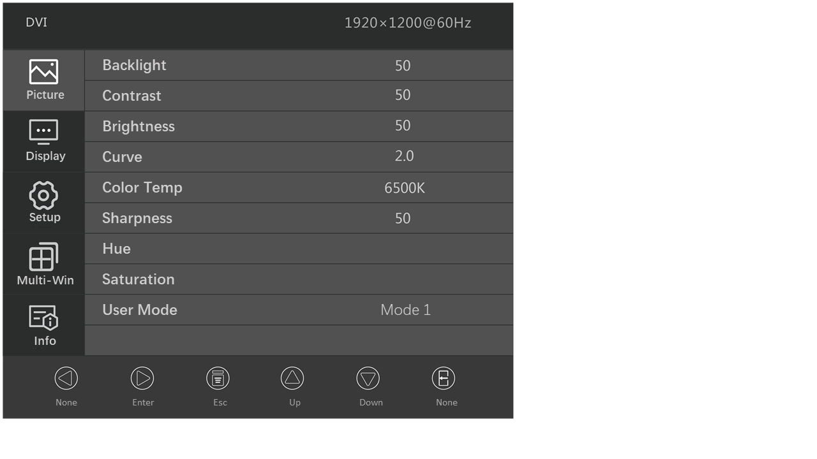

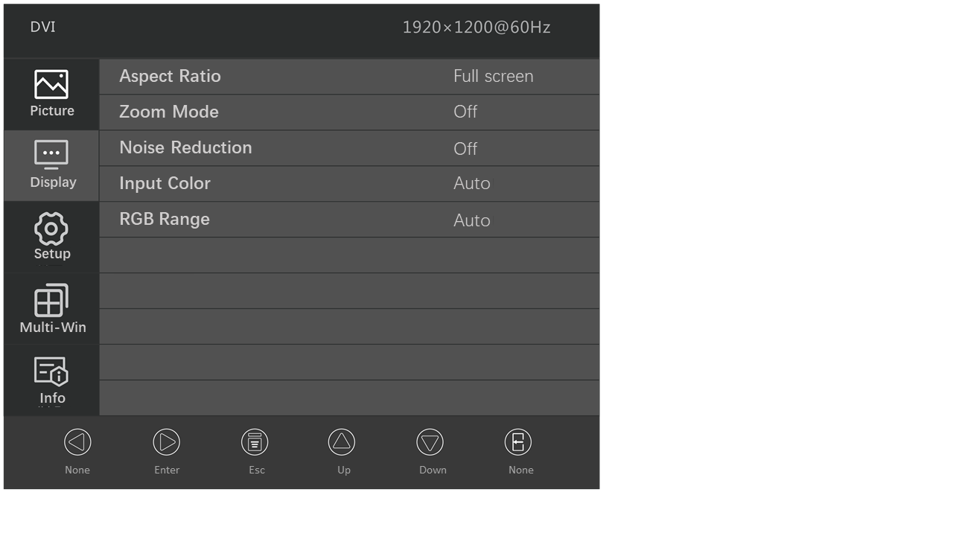

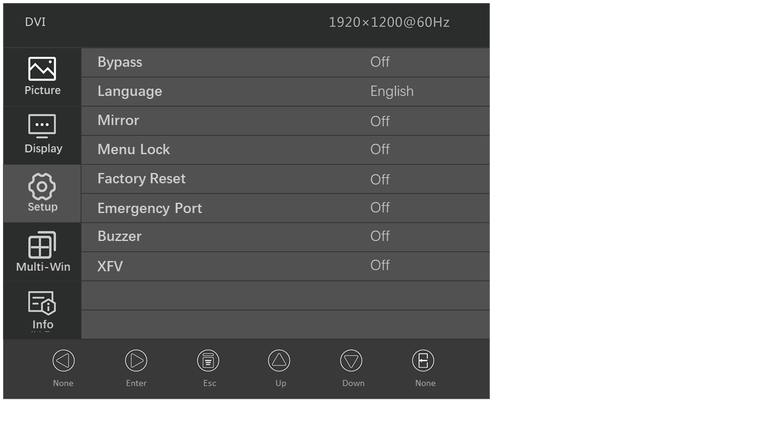

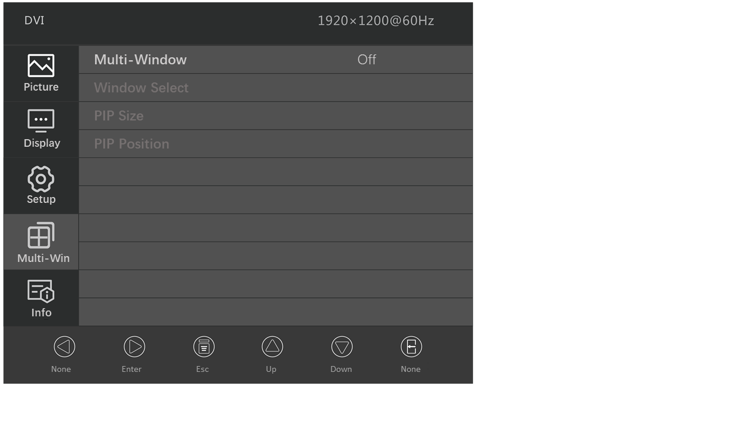

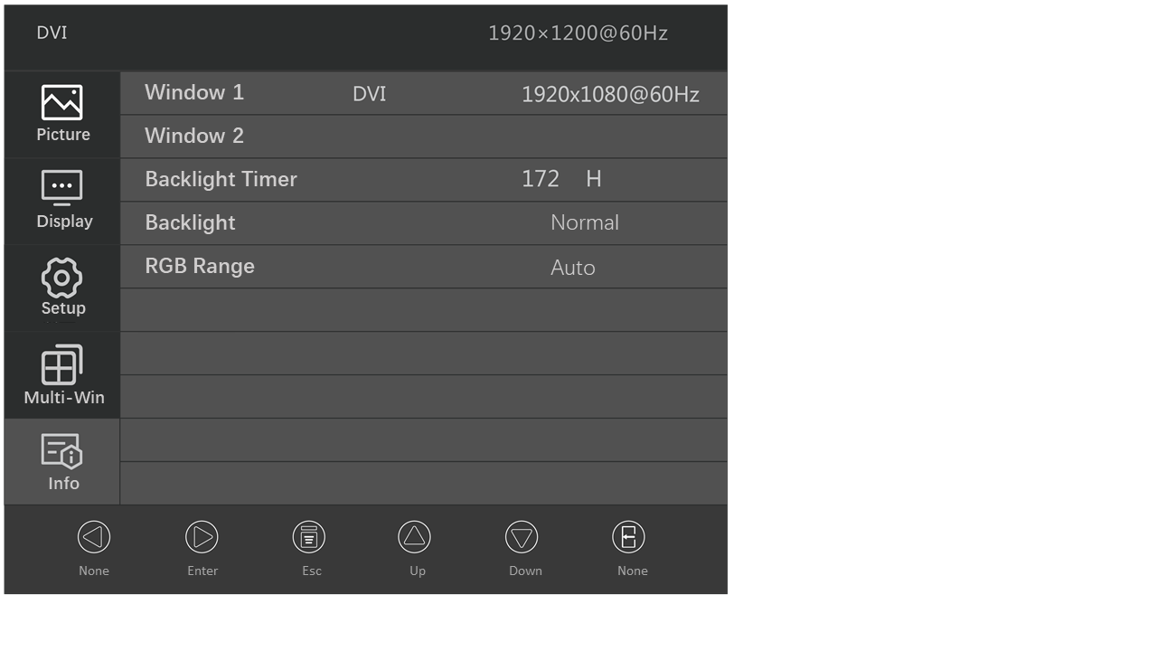

|  |  |
| --- | --- |
|  | **Note:**The menu provided here is for illustrative purposes only, and may differ from the actual menu, as menus can vary between models. |

The specific menu options and parameters are shown below:

|  |  |  |  |
| --- | --- | --- | --- |
| Menu page | Menu operations | Parameter and specification | Default value |
| Picture | Backlight | 0-100 | 80 |
| Contrast | 0-100 | 50 |
| Brightness | 0-100 | 50 |
| Curve | 1.8/2.0/2.2/2.4/2.6/USER-G/USER-P/ USER-S /DICOM | 2.0 |
| Color Temp | 6500K/7500K/9300K/USER | 6500K |
| Sharpness | 0-100 | 50 |
| Hue | 0-100 | 50 |
| Saturation | 0-100 | 50 |
| User Mode | Mode 1/ Mode 2/ Mode 3/ Mode 4/ Mode 5/Mode 6 | Mode 1 |
| Display | Aspect Ratio | Full screen/4:3/5:4/16:9/1:1/ Min ratio /  Max ratio | Full screen |
| Zoom Mode | Off/5%/10%/15%/20% | Off |
| Noise  Reduction | Off/ Low/ Middle/ High | Off |
| Input Color | RGB/ YPBPR/ Auto | Auto |
| RGB range | Full/ Limit/ Auto | Auto |
| Setup | Bypass | On/Off | Off |
| Language | 简体中文  /English  / Español  / Português  / Italiano  /Русский  / Deutsch  /日本語 | English |
| Mirror | On  /Off | Off |
| Menu Lock | On  /Off | Off |
| Factory Reset | On  /Off | Off |
| Emergency Port | HDMI1/HDMI2/SDI1/SDI2  /DVI1/DVI2/DVI3/DVI4/DVI5/DVI6/DVI7/Off | Off |
| Buzzer | On  /Off | Off |
| XFV | On  /Off | Off |
| Multi-window setting | Multi-Window | Off/PIP/PBP1/PBP2/ Triple/ Quad | Off |
| Window Select | Window 1  / Window 2  / Window 3  / Window 4  / All Windows | Window 1 |
| PIP Size | Small/ Medium/ Large/Huge | Medium |
| PIP Position | Top Left/ Top Right/ Bottom Left/ Bottom Right | Top Left |
| Info | Window 1 | Channel selection | Resolution information |
| Window 2 | Channel selection | Resolution information |
| Window 3 | Channel selection | Resolution information |
| Window 4 | Channel selection | Resolution information |
| Backlight Timer | Time display | Unit: hours |

## Operating OSD menu

### Outbound menu

After opening the product, press any key to call the navigation menu, then press the  key, and the OSD menu will be displayed on the product screen. If the next operation is not performed within 15 seconds, the OSD menu will disappear again.

### Exit menu

There are two ways to exit the OSD menu:

1. On the sub menu page, press  key to return to the previous option of the current operation, then press  key to exit the menu.

2. If nothing is done within 15 seconds, the menu will automatically disappear.

### Unlock menu

There are two ways to unlock the OSD menu (after the menu lock function is turned on, the menu automatically locks after 15s of inactivity):

1. After turning on the product, directly press the  key to unlock the menu, and you will see the prompt menu of key unlocking success. At this time, operate the key normally and call up the corresponding menu.

2. After turning on the product, press any key (other than  and shutdown key) to bring up the key lock prompt menu, and then press the  key under the prompt menu to unlock the key.

### Adjust backlight brightness

The operation is as follows:

1. Press any key to call the navigation menu, and then press the  "Exhale" menu. By default, the [Image] page will be displayed first.

2. Press the  key to move the cursor to enter the image sub menu.

3. Press / to move the cursor to [Backlight].

4. Users can set the backlight value of the screen by increasing or decreasing the value of the progress bar by pressing / as needed.

Adjustment step: 1, default value: 50.

|  |  |
| --- | --- |
|  | **Note:**  The LED backlight has a certain service life.  We recommend that you use the screen brightness value of 50 to prolong the service life of the product. |

### Adjust contrast

1. Press any key to call the navigation menu, and then press the  "Exhale" menu. By default, the [Image] page will be displayed first.

2. Press the  key to move the cursor to enter the image sub menu.

3. Press / to move the cursor to [Contrast].

4. Users can set the contrast of the screen by increasing or decreasing the value of the progress bar by pressing / as needed.

Adjustment step: 1.

Default: 50.

### Adjust digital brightness

1. Press any key to call the navigation menu, and then press the  "Exhale" menu. By default, the [Image] page will be displayed first.

2. Press the  key to move the cursor to enter the image sub menu.

3. Press / to move the cursor to [Brightness].

4. Users can set the digital brightness of the screen by pressing / to increase or decrease the value of the progress bar as needed.

Adjustment step: 1.

Default: 50.

### Select curve

The operation is as follows:

1. Press any key to call the navigation menu, and then press the  "Exhale" menu. By default, the [Image] page will be displayed first.

2. Press the  key to move the cursor to enter the image sub menu.

3. Press / to move the cursor to [Curve].

4. Users can select different curves according to their needs by pressing /.

Option: GAMMA1.8, GAMMA2.0, GAMMA2.2, GAMMA2.4, GAMMA2.6, USER-G, USER-P, USER-S and DICOM.

Default: GAMMA2.0.

|  |  |
| --- | --- |
|  | **Note:**  The built-in calibration of the product is accurately calibrated and conforms to DICOM standard. DICOM calibration can ensure that medical images show more obvious gray scale. We suggest that DICOM calibration should be used for most medical image diagnosis. |

### Adjust color temperature

The operation is as follows:

1. Press any key to call the navigation menu, and then press the  "Exhale" menu. By default, the [Image] page will be displayed first.

2. Press the  key to move the cursor to enter the image sub menu.

3. Press / to move the cursor to [Color Temp].

4. Users can set different color temperatures according to their needs by pressing /.

Options: 6500K, 7500K, 9300K and USER.

Default: 6500K.

### Adjust sharpness

The operation is as follows:

1. Press any key to call the navigation menu, and then press the  "Exhale" menu. By default, the [Image] page will be displayed first.

2. Press the  key to move the cursor to enter the image sub menu.

3. Press / to move the cursorto [Sharpness].

4. Users can set different sharpness according to their needs by pressing /.

Adjustment step: 10.

Default: 50.

### Adjust tone

The operation is as follows:

1. Press any key to call the navigation menu, and then press the  "Exhale" menu. By default, the [Image] page will be displayed first.

2. Press the  key to move the cursor to enter the image sub menu.

3. Press / to move the cursor to [Hue].

4. Users can set the hue value by increasing or decreasing the value of the progress bar according to the /.

Adjustment step: 1.

Default: 50.

### Adjust saturation

The operation is as follows:

1. Press any key to call the navigation menu, and then press the  "Exhale" menu. By default, the [Image] page will be displayed first.

2. Press the  key to move the cursor to enter the image sub menu.

3. Press / to move the cursor to [Saturation].

4. Users can set the saturation value by increasing or decreasing the value of the progress bar by pressing /.

Adjustment step: 1.

Default: 50.

### Adjust user mode

The operation is as follows:

1. Press any key to call the navigation menu, and then press the  "Exhale" menu. By default, the [Image] page will be displayed first.

2. Press the  key to move the cursor to enter the image sub menu.

4. Press / to move the cursor to [User Mode].

5. Users can switch user modes by pressing /, and mode 1, 2, 3, 4, 5 and 6 are optional.

Default: mode 1.

### Adjust aspect ratio

The operation is as follows:

1. Press any key to call the navigation menu, then press the  "Exhale" menu, and the [Image] page will be displayed by default.

2. Press / to move the cursor to [Display].

3. Press  to enter the sub menu setting interface.

4. Press / to move the cursor to [Aspect Ratio].

5. Users can set different scale modes by pressing / according to the actual input signal.

Options: Full screen, 4: 3, 5: 4, 16: 9, 1: 1, Min ratio, max ratio.

Default: Full screen.

### Adjust zoom mode

The operation is as follows:

1. Press any key to call the navigation menu, then press the  "Exhale" menu, and the [Image] page will be displayed by default.

2. Press / to move the cursor to [Display].

3. Press  to enter the sub menu setting interface.

4. Press / to move the cursor to [Zoom Mode].

5. Users can choose different magnification modes by pressing / according to their needs.

Options: Off, 5%, 10%, 15% and 20%.

Default: Off.

### Adjust noise reduction

The operation is as follows:

1. Press any key to call the navigation menu, then press the  "Exhale" menu, and the [Image] page will be displayed by default.

2. Press / to move the cursor to [Display].

3. Press  to enter the sub menu setting interface.

4. Press / to move the cursor to [Noise Reduction].

5. Users can press / to switch in different noise reduction modes according to their needs,

Options: OFF, Low, Middle and High.

Default: Off.

### Adjust the color format

The operation is as follows:

1. Press any key to call the navigation menu, then press the  "Exhale" menu, and the [Image] page will be displayed by default.

2. Press / to move the cursor to [Display].

3. Press  to enter the sub menu setting interface.

4. Press / to move the cursor to [Input Color].

5. Users can press / to switch between input color formats according to their needs.

Options: Auto, RGB, YPBPR.

Default: Auto.

### Adjust RGB range

The operation is as follows:

1. Press any key to call the navigation menu, then press the  "Exhale" menu, and the [Image] page will be displayed by default.

2. Press / to move the cursor to [Display].

3. Press  to enter the sub menu setting interface.

4. Press / to move the cursor to [RGB range].

5. Users can press / to switch between RGB ranges according to their needs.

Options: Auto, Full, Limit.

Default: Auto.

### Adjust bypass mode

The operation is as follows:

1. Press any key to call the navigation menu, and then press the  "Exhale" menu. By default, the [Image] page will be displayed first.

2. Press / to move the cursor to [Settings].

3. Press  to enter the sub menu setting interface.

4. Press / to move the cursor to [Bypass].

5. Users can enable or disable the direct mode by pressing /.

Option: On, Off.

Default: Off.

### Set language

The operation is as follows:

1. Press any key to call the navigation menu, then press the  "Exhale" menu, and the [Image] page will be displayed by default.

2. Press / to move the cursor to [Settings].

3. Press  to enter the sub menu setting interface.

4. Press / to move the cursor to [Language]

5. Users can select the language by pressing /.

Options: English, 简体中文, Español, Português, Italiano,

Русский, Deutsch, 日本語.

Default: 简体中文(domestic), English (export).

### Adjust mirror image

The operation is as follows:

1. Press any key to call the navigation menu, then press the  "Exhale" menu, and the [Image] page will be displayed by default.

2. Press / to move the cursor to [Settings].

3. Press  to enter the sub menu setting interface.

4. Press / to move the cursor to [Mirror].

5. Users can press / to select the mirror switch.

Options: On, Off.

Default: Off.

### Adjust menu lock

The operation is as follows:

1. Press any key to call the navigation menu, then press the  "Exhale" menu, and the [Image] page will be displayed by default.

2. Press / to move the cursor to [Settings].

3. Press  to enter the sub menu setting interface.

4. Press / to move the cursor to [Menu Lock].

5. Users can press / to unlock the menu.

Options: On, Off.

Default: Off.

### Adjust factory reset

The operation is as follows:

1. Press any key to call the navigation menu, then press the  "Exhale" menu, and the [Image] page will be displayed by default.

2. Press / to move the cursor to [Settings].

3. Press  to enter the sub menu setting interface.

4. Press / to move the cursor to [Factory Reset].

5. Press / to switch the factory reset option.

6. Press  to confirm the selection.

Options: On, Off.

Default: Off.

### Adjust emergency passage

The operation is as follows:

1. Press any key to call the navigation menu, then press the  "Exhale" menu, and the [Image] page will be displayed by default.

2. Press / to move the cursor to [Settings].

3. Press  to enter the sub menu setting interface.

4. Press / to move the cursor to [Emergency Port].

5. Press / to switch the information source option corresponding to the emergency channel.

Options: HDMI1, HDMI2, SDI1, SDI2, DVI1, DVI2, DVI3, DVI4, DVI5, DVI6, DVI7, Off.

Default: Off.

### Adjust buzzer

The operation is as follows:

1. Press any key to call the navigation menu, then press the  "Exhale" menu, and the [Image] page will be displayed by default.

2. Press / to move the cursor to [Settings].

3. Press  to enter the sub menu setting interface.

4. Press / to move the cursor to [Buzzer].

5. Press the switch option of / switch buzzer.

Options: On, Off.

Default: Off.

### Adjust XFV function

The operation is as follows:

1. Press any key to call the navigation menu, then press the  "Exhale" menu, and the [Image] page will be displayed by default.

2. Press / to move the cursor to [Settings].

3. Press  to enter the sub menu setting interface.

4. Press / to move the cursor to [XFV].

5. Press the / to switch the switch option of the film reading lamp.

Options: On, Off.

Default: Off.

### Adjust multi-window mode

The operation is as follows:

1. Press any key to call the navigation menu, then press the  "Exhale" menu, and the [Image] page will be displayed by default.

2. Press / to move the cursor to [Multi-window Settings].

3. Press  to enter the sub menu setting interface.

4. Press / to move the cursor to [Multi-window].

5. Press / to switch the multi-window option.

Options: Off, PIP, PBP 1, PBP 2, Triple, Quad.

Default: Off.

### Select window

The operation is as follows:

1. Press any key to call the navigation menu, then press the  "Exhale" menu, and the [Image] page will be displayed by default.

2. Press / to move the cursor to [Multi-window Settings].

3. Press  to enter the sub menu setting interface.

4. Press / to move the cursor to [Window Select].

5. Press / to select Windows.

Options: Window 1, Window 2, Window 3, Window 4, All Window. There will be different options according to the choice of multi-window mode.

Default: Window 1.

### Adjust PIP size

The operation is as follows:

1. Press any key to call the navigation menu, then press the  "Exhale" menu, and the [Image] page will be displayed by default.

2. Press / to move the cursor to [Multi-window Settings].

3. Press  to enter the multi-window setting sub menu interface.

4. Press / to move the cursor to [PIP size].

5. Press / to switch the size of PIP window.

Options: Small, Medium, Large, Huge.

Default: Medium.

### Adjust PIP position

The operation is as follows:

1. Press any key to call the navigation menu, then press the  "Exhale" menu, and the [Image] page will be displayed by default.

2. Press / to move the cursor to [Multi-window Settings].

3. Press  to enter the multi-window setting sub menu interface.

4. Press / to move the cursor to [PIP position].

5. Press / to switch the PIP window position.

Options: Top Left, Top Right, Bottom Left, Bottom Right.

Default: Top Left.

## Shortcut key

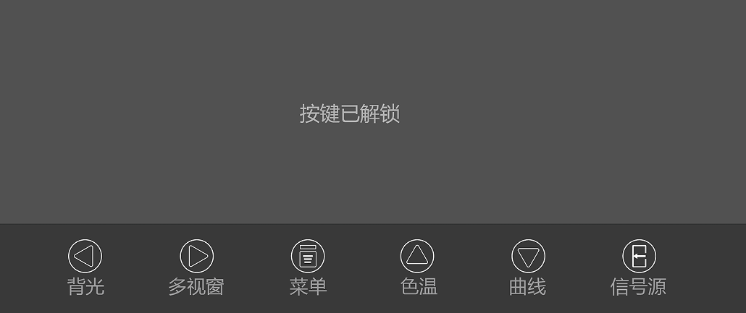Navigation icon when the XFV function is not turned on:

Backlight

Multi-Window

Menu

Color Temp

Curve

Source

Navigation icon when the XFV function is turned on:

XFV

Multi-Window

Menu

Color Temp

Curve

Source

### Unlock key

The operation is as follows:

1. Press any key (other than the right key and the power key) to call out the key lock prompt menu.

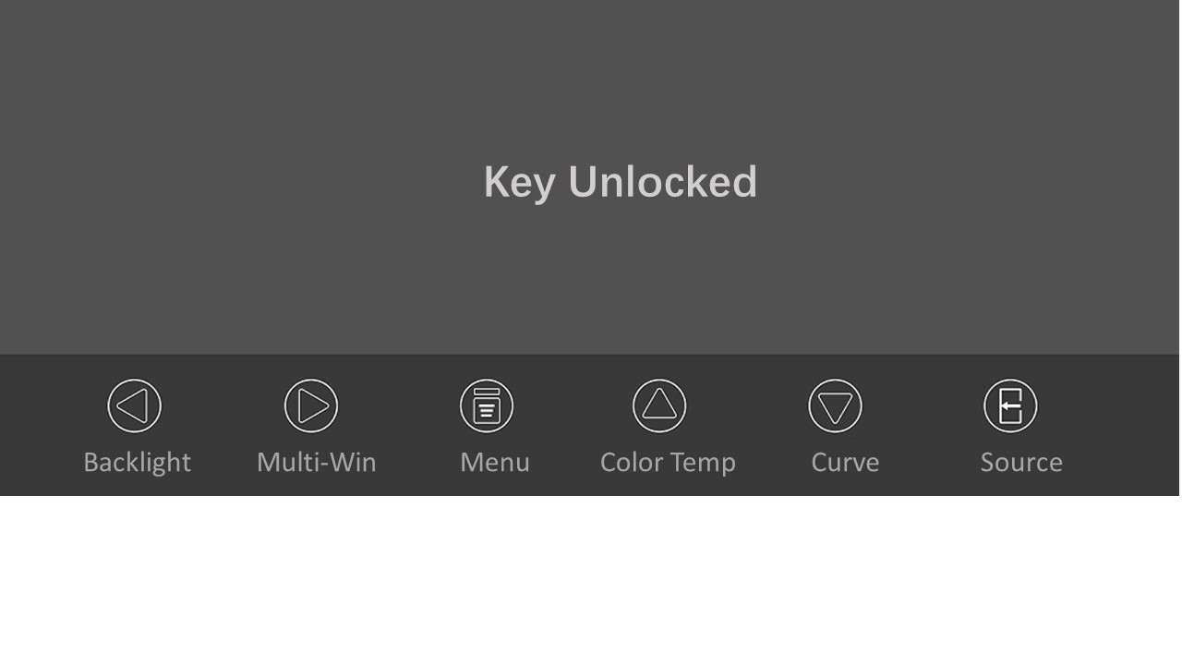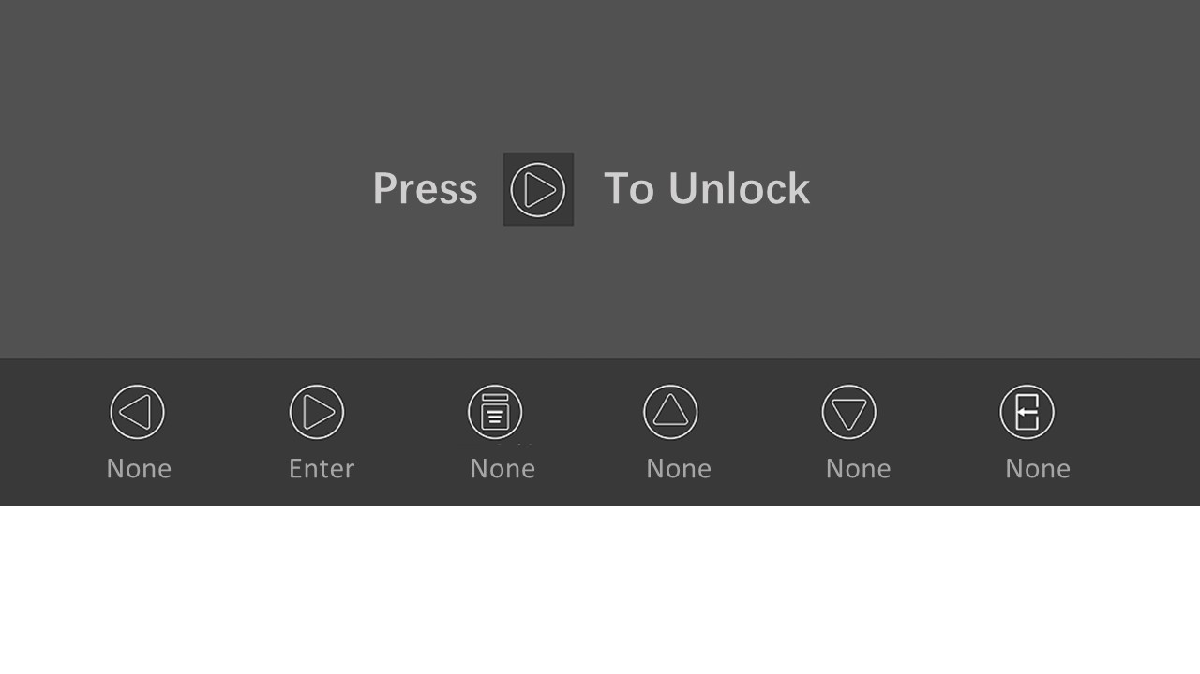2. Then press  to unlock the menu, and bring up the "key unlocked" menu.

### Color temperature shortcut key

The operation is as follows:

1. Press any key to call out the navigation menu, and then press  to bring up the "Color Temp" menu.

2. Press / to switch color temperature options: 6500K, 7500K, 9300K and USER.

3. Press  to exit the menu.

### F:\项目资料\2022-说明书、规格书CCC认证换版汇总\E550E\说明书配图\幻灯片8.JPGCurved shortcut key

The operation is as follows:

1. Press any key to call out the navigation menu, and then press  to bring up the "Curve" menu.

2. Press /to switch curve options: GAMMA1.8, GAMMA2.0, GAMMA2.2, GAMMA2.4, GAMMA2.6, USER-G, USER-P, USER-S and DICOM.

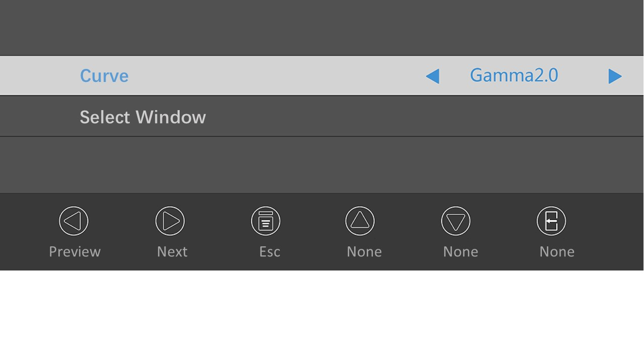3. Press  to exit the menu.

### Backlight brightness shortcut key (the XFV function is off)

The operation is as follows:

1. Press any key to call out the navigation menu, and then press  to bring up the "Backlight" menu.

2. Users can set the backlight value of the monitor according to their needs, and increase or decrease the value according to /. The default value is 50.

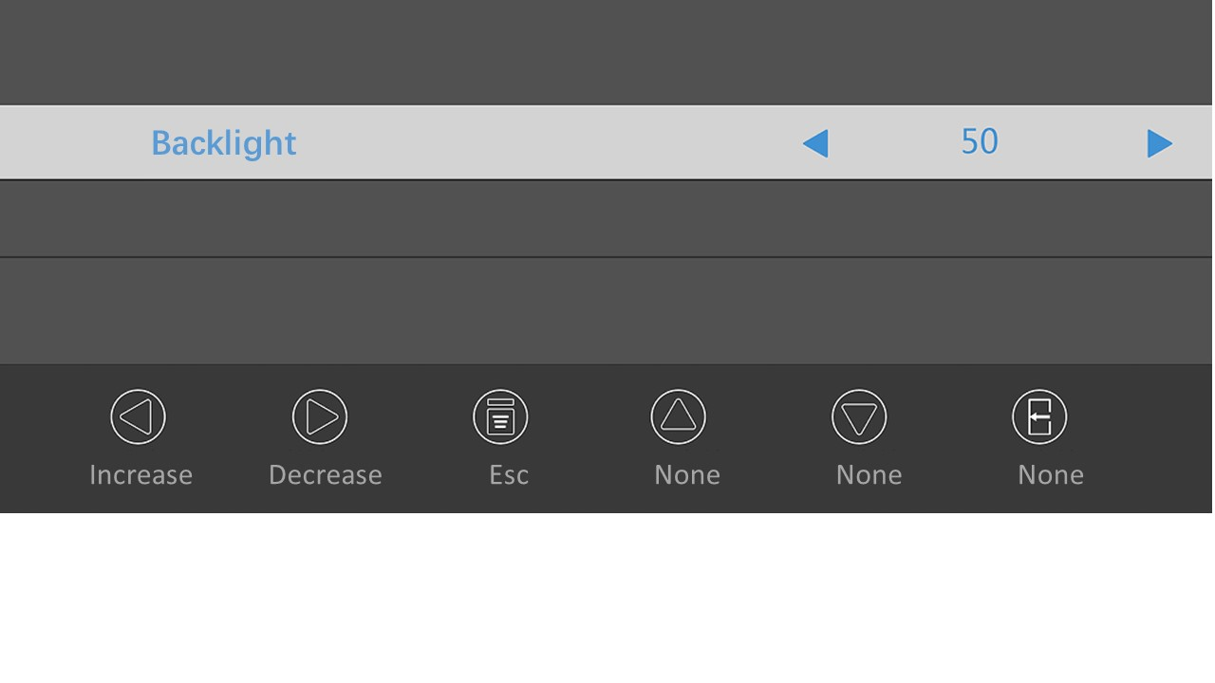3. Press  to exit the menu.

### XFV shortcut key (the XFV function is on)

The operation is as follows:

1. Press any key to call out the navigation menu, and then press  to adjust the XFV function.

2. Users can set the XFV function according to their needs, which can be adjusted by pressing  according to the order of full screen, left half screen, right half screen and off.

### Multiple window shortcut keys

The operation is as follows:

1. Press any key to call out the navigation menu, and then press  to bring up the "Multiple-Window" menu.

2. Press / to switch the multi-window options: Off, PIP, PBP 1, PBP 2, Triple and Quad.

3. Press  to confirm the selection.

4. Press  to exit the menu.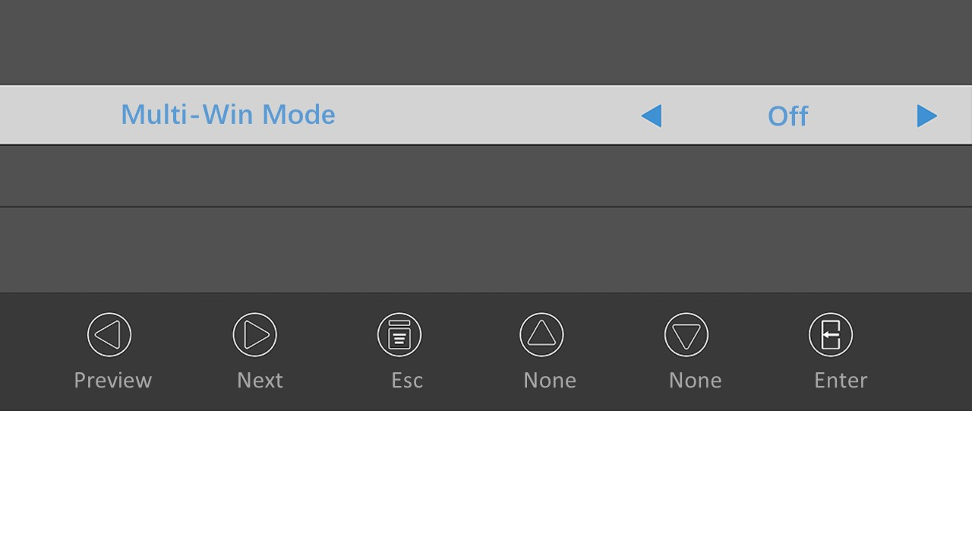

### Signal source shortcut key

The operation is as follows:

1. Press any key to call out the navigation menu, and then press  to bring up the "source" menu.

2. Press  to switch the input signal options: HDMI, SDI1, SDI2, SDI3, SDI4, SDI4x3G, DVI and DP.

3. After selecting the required signal source, stop operating the key, and the signal source will automatically switch to the selected channel.

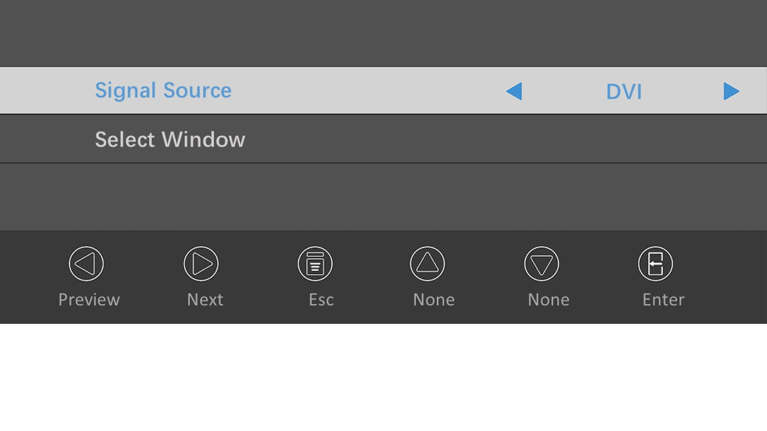4. Press  to exit the menu.

## Video Fusion Control

The display can support up to 6 windows on the same screen, which can be configured with JUSHA surgical window layout control system software. Please refer to the operating guide of the JUSHA software for details. When setting windows layout with the JUSHA software, the optional ways are as follows:

|  |  |  |  |
| --- | --- | --- | --- |
| **Type** | **Input Source** | **Optional Layout** | **Remarks** |
| Window Layouts  For Endoscopy | HDMI1, HDMI2, DP, DVI7, SDI1, SDI2, DVI1, DVI2, DVI3, DVI4, DVI5, DVI6 | Single windows  PBP  PIP  Four windows | While one of DP, DVI1, DVI2, DVI3, DVI4, DVI5, DVI6, SDI1, SDI2 is in use, the others are not optional. |
| Window Layouts  For Intervention | SDI1, SDI2, DVI1, DVI2, DVI3, DVI4, DVI5, DVI6 | 18 layouts in total, and up to 6 windows at the same time, please refer to the operating guide of the software for details. | Only one is supported between interlaced and progressive scan format at the same time, which means that one is in use, the other format is not supported at the same time. |
| Customized Window Layouts | SDI1, SDI2, DVI1, DVI2, DVI3, DVI4, DVI5, DVI6 | Up to 6 windows at the same time, the position and size of windows can be adjusted by users. | Only one is supported between interlaced and progressive scan format at the same time, which means that one is in use, the other format is not supported at the same time. |

# Important information

## Technical specification

|  |  |
| --- | --- |
| Power supply voltage | AC input: AC 100-240V, 4A (MAX) |
| Operating power | <300W(Typical) |
| Liquid crystal display | 54.64 inches, TFT color LCD screen |
| Max brightness | 800 cd/m2(TYP.) |
| Calibrated brightness | 450 cd/m2 (MAX.) |
| Visible angle | 178°horizontally and 178°vertically (CR≥10) |
| Pixel distance | (H)0.315 ×(V) 0.315 (mm) |
| Resolution | (H) 3840 × (V) 2160(MAX) |
| Visible size | (H) 1209.6 × (V) 680.4 (mm) |
| Video input interface | HDMI1.4 * 1  HDMI2.0 * 1  Single-link DVI-D * 7  DP1.2 * 1  3G-SDI * 1  12G-SDI * 1 |
| Video output interface | DVI-D * 1 |
| Power output | DC 5V 2A * 2 |
| Operating environment | Temperature: 0 ℃ ~ 40 ℃  Humidity: 20%~85% (Non condensation)  Air pressure: 700hpa~1060hpa |
| Storage and transportation environment | Temperature:-20 ℃ ~ 40 ℃  Humidity: 10%~85% (Non condensation)  Air pressure: 200hpa~1060hpa |
| Authentication | CCC, CE |

|  |  |
| --- | --- |
|  | **Note:**  This product specification is subject to change without prior notice. |

## Environmental protection information

The product’s raw material conforms to RoHS requirement, ensuring they are free from hazardous substances such as lead, mercury, etc.

## Safety standard

Safety standards：

|  |  |
| --- | --- |
| Safety standard for medical display | GB4943.1-2022  IEC 60601-1:2012  EN 60601-1:2013 |

## Electromagnetic compatibility

The product’s electromagnetic compatibility conforms to the following conditions:

|  |  |
| --- | --- |
| Electromagnetic interference | GB17625.1-2022  GB/T9254.1-2021  IEC 60601 1-2: 2014.  EN 60601-1-2:2015 |

|  |
| --- |
| Warning  This product is Class A, which may cause radio interference in living environment. In this case, users may need to take practical measures against interference. |

## Guidance and Manufacturer’s Declaration

Below cables information are provided for EMC reference.

|  |  |  |  |  |
| --- | --- | --- | --- | --- |
| **Cable** | **Max. cable length,**  **Shielded/unshielded** | | **Number** | **Cable classification** |
| AC Power Line | 1.8m | Unshielded | 1 Set | AC Power |
| DVI Cable | 2m | shielded | 1 Set | Signal |
| DP Cable | 2m | shielded | 1 Set | Signal |
| HDMI Cable | 2m | shielded | 1 Set | Signal |
| SDI Cable | 5m | shielded | 1 Set | Signal |

**Important information regarding Electro Magnetic Compatibility (EMC)**

This electrical medical equipment needs special precautions regarding EMC and put into service according to the EMC information provided in the user manual , The equipment conforms to this IEC 60601-1-2:2014 standard for both immunity and emissions. Nevertheless, special precautions need to be observed:

The equipment with no ESSENTIAL PERFORMANCE is intended used in Professional healthcare facility environment except for near active HF SURGICAL EQUIPMENT and the RF shielded room of an ME SYSTEM for magnetic resonance imaging, where the intensity of EM DISTURBANCES is high.

WARNING: Use of this equipment adjacent to or stacked with other equipment should be avoided because it could result in improper operation. If such use is necessary, this equipment and the other equipment should be observed to verify that they are operating normally.

The use of accessories and cables other than those specified or provided by the manufacturer of this equipment could result in increased electromagnetic emissions or decreased electromagnetic immunity of this equipment and result in improper operation.

WARNING: Portable RF communications equipment (including peripherals such as antenna cables and external antennas) should be used no closer than 30 cm (12 inches) to any part of the S9820, including cables specified by the manufacturer. Otherwise, degradation of the performance of this equipment could result.

When the AC input voltage is interrupted, the equipment will shut down and if the power supply restored, it should be recovered by operator manually, this degradation could be accepted because it will not lead to unacceptable risks and it will not result in the loss of basic safety or essential performance.

**EMI Compliance Table (Table 1)**

**Table 1 - Emission**

|  |  |  |
| --- | --- | --- |
| **Phenomenon** | **Compliance** | **Electromagnetic environment** |
| RF emissions | CISPR 11  Group 1, Class A | Professional healthcare facility environment |
| Harmonic distortion | IEC 61000-3-2  Class A | Professional healthcare facility environment |
| Voltage fluctuations and flicker | IEC 61000-3-3  Compliance | Professional healthcare facility environment |

**NOTE** The EMISSIONS characteristics of this equipment make it suitable for use in industrial areas and hospitals (CISPR 11 class A). If it is used in a residential environment (for which CISPR 11 class B is normally required) this equipment might not offer adequate protection to radio-frequency communication services. The user might need to take mitigation measures, such as relocating or re-orienting the equipment.

**EMS Compliance Table (Table 2-5)**

**Table 2 - Enclosure Port**

|  |  |  |
| --- | --- | --- |
| **Phenomenon** | **Basic EMC standard** | **Immunity test levels** |
| **Professional healthcare facility environment** |
| Electrostatic Discharge | IEC 61000-4-2 | ±8 kV contact  ±2kV, ±4kV, ±8kV, ±15kV air |
| Radiated RF EM field | IEC 61000-4-3 | 3V/m  80MHz-2.7GHz  80% AM at 1kHz |
| Proximity fields from RF wireless communications equipment | IEC 61000-4-3 | Refer to table 3 |
| Rated power frequency magnetic fields | IEC 61000-4-8 | 30A/m  50Hz or 60Hz |

**Table 3 – Proximity fields from RF wireless communications equipment**

|  |  |  |
| --- | --- | --- |
| **Test frequency**  **(MHz)** | **Band**  **(MHz)** | **Immunity test levels** |
| **Professional healthcare facility environment** |
| 385 | 380-390 | Pulse modulation 18Hz, 27V/m |
| 450 | 430-470 | FM, ±5kHz deviation, 1kHz sine, 28V/m |
| 710 | 704-787 | Pulse modulation 217Hz, 9V/m |
| 745 |
| 780 |
| 810 | 800-960 | Pulse modulation 18Hz, 28V/m |
| 870 |
| 930 |
| 1720 | 1700-1990 | Pulse modulation 217Hz, 28V/m |
| 1845 |
| 1970 |
| 2450 | 2400-2570 | Pulse modulation 217Hz, 28V/m |
| 5240 | 5100-5800 | Pulse modulation 217Hz, 9V/m |
| 5500 |
| 5785 |

**Table 4 – Input a.c. power Port**

|  |  |  |
| --- | --- | --- |
| **Phenomenon** | **Basic EMC standard** | **Immunity test levels** |
| **Professional healthcare facility environment** |
| Electrical fast transients/burst | IEC 61000-4-4 | ±2 kV  100kHz repetition frequency |
| Surges Line-to-line | IEC 61000-4-5 | ±0.5 kV, ±1 kV |
| Surges Line-to-ground | IEC 61000-4-5 | ±0.5 kV, ±1 kV, ±2 kV |
| Conducted disturbances induced by RF fields | IEC 61000-4-6 | 3V, 0.15MHz-80MHz  6V in ISM bands between 0.15MHz and 80MHz  80%AM at 1kHz |
| Voltage dips | IEC 61000-4-11 | 0% UT; 0.5 cycle  At 0º, 45º, 90º, 135º, 180º, 225º, 270º and 315º |
| 0% UT; 1 cycle  and  70% UT; 25/30 cycles  Single phase: at 0º |
| Voltage interruptions | IEC 61000-4-11 | 0% UT; 250/300 cycles |

**Table 5 – Signal input/output parts Port**

|  |  |  |
| --- | --- | --- |
| **Phenomenon** | **Basic EMC standard** | **Immunity test levels** |
| **Professional healthcare facility environment** |
| Electrical fast transients/burst | IEC 61000-4-4 | ±1 kV  100kHz repetition frequency |
| Conducted disturbances induced by RF fields | IEC 61000-4-6 | 3V, 0.15MHz-80MHz  6V in ISM bands between 0.15MHz and 80MHz  80%AM at 1kHz |

# Statement

## Legal Statement

The auxiliary equipment connected to the display shall be certified by the corresponding IEC standard (data processing equipment shall conform to IEC 60950-1 standard, and medical equipment IEC 60601-1). In addition, all configurations shall conform to IEC 60601-1-1. Anyone who connects other devices to a signal output or input interface for system configuration must ensure that the system conforms to IEC 60601-1 -1.

 The worker responsible for connecting the display to the system must ensure that the equipment installed conforms to IEC 60601-1-1. In case of doubt, please contact in time the Technical Service Department or the local sales representative of Nanjing Jusha Display Technology Co., Ltd.

Nanjing Jusha Display Technology Co., Ltd. sells products through other medical equipment manufacturers, distributors and dealers and, while purchasing the product, it is required to consult the seller if corresponding product maintenance service is provided.

Nanjing Jusha Display Technology Co., Ltd. shall not bear or authorize anyone to bear any responsibility for the sale or use of the products. In order to ensure the correct use and maintenance of the products of Nanjing Jusha Display Technology Co., Ltd., please refer to relevant documents and user manual of the product or the label on the product and on the package.

Please be noted that the system configuration, software, applications, customer data, and the operational control of the system will affect the performance of product. Although our products are compatible with many systems, the specific functional realization by customers will be different. If the product is suitable for a specific purpose or the application is determined by the customer, Nanjing Jusha Display Technology Co., Ltd. will not guarantee it.

In particular, Nanjing Jusha Display Technology Co., Ltd. denies any form of warranty, whether express, implied and/or legal, including but not limited to any guarantee for the applicability, fitness and/or for a particular purpose, as well as for any infringement upon JUSHA product or service. We hereby expressly exclude and deny any warranty, representation and/or guarantee of any kind, nature or degree, whether implied, express and /or it causes or results in any law, statute, commercial practice, custom, trade related problems or otherwise.

Nanjing Jusha Display Technology Co., Ltd., and/or its distributors and/or dealers have no direct or indirect responsibility for any damage caused by the following factors: the damage caused by any special, accidental, indirect, punitive, disciplinary or indirect causes, including but not limited to shipment delay, delivery failure, product failure, product design or production, inability to use these products and services, future business losses or loss of profits, or other reason; any responsibility related to or arising from the purchase, sale, leasing, renting, installation, or use of products of Nanjing Jusha Display Technology Co., Ltd. These terms and conditions, or any terms relating to the composition of these terms and conditions shall be observed.

The restrictions and/or exclusions described herein may or may not apply to certain jurisdictions that do not allow exclusions, special provisions or liability limitations. In that case, the liability would be limited to the maximum extent permitted by the law of the jurisdiction.

All information contained in this User Manual, including all designs and related materials, is owned by Nanjing Jusha Display Technology Co., Ltd., and the Company shall retain all patents, copyrights and other proprietary rights to the manual. Without the explicit authorization of Nanjing Jusha Display Technology Co., Ltd., it is forbidden to plagiarize the product design, or duplicate, use and sell the product.

## Maintenance Statement

Nanjing Jusha Display Technology Co., Ltd. guarantees to provide free repair for part damage and other problems arising from production technology conforming to repair conditions within three years since the purchase date.

The quality warranty shall only apply to the products provided by Nanjing Jusha Display Technology Co., Ltd., and the products with problems arising from the equipment of other third party shall not fall within the scope of warranty.

|  |  |
| --- | --- |
|  | **Note:**  Before returning equipment to Nanjing Jusha Display Technology Co., Ltd. for repair, it is required to contact and obtain permission of Nanjing Jusha Display Technology Co., Ltd. in advance. |

**Please keep well the original package and, if the product is transported again, the original package must be selected. No heavy load on the package is permitted during transportation.**

The user shall not maintain or repair products at a place other than the after- sale service point of Nanjing Jusha Display Technology Co., Ltd., the original equipment number shall not be modified or removed. In order to obtain this quality assurance, the use shall not be contrary to the requirements of this manual, and the quality assurance will fail in such cases.

This product provides limited liability quality assurance. **Nanjing Jusha Display Technology Co., Ltd. is not responsible for the direct, indirect and accidental damage caused by the users themselves.**Users should pay attention to the system settings, software, application programs, user data and operation control of the product. All of the above factors will affect the performance of product. This product can be compatible with many systems, and users may decide to use the characteristics and functions of this product in their own discretion.

## Statement of Ownership

Nanjing Jusha Display Technology Co., Ltd. reserves all patents, copyrights and other ownership of the User Manual. Without the explicit authorization of Nanjing Jusha Display Technology Co., Ltd., it is forbidden to plagiarize the product design, or duplicate, use and sell the product.

# Contact information

Nanjing Jusha Display Technology Co., Ltd.

TEL：025-83305050

FAX：025-58783273

Free hotline：400-820-0556 800-820-0556

Address: 8A,Block 1,Nanjing International Service Outsourcing Mansion No.301, Hanzhongmen Street, Nanjing, Jiangsu, China

Website：cn.jusha.com.cn